# Island Wake Simulations

# Case1: Medium Resolution 2D run

The wake behind an island due to an ocean current is modeled in this initial study as the two-dimensional flow past a circular cylinder. Thus the island is idealized as a circular shape with constant cross-sectional area (into the ocean) and the current is uniform with depth. The flow is also idealized to be two-dimensional as might be the case under fairly high stable stratification.   
  
The mesh used for this case is shown below. It is a C-mesh topology containing 280 points in streamwise/azimuthal direction and 128 points in the normal direction. The mesh points are highly clustered near the cylinder surface in order to resolve the boundary layers. There is also clustering along the wake centerline and along vertical lines near emanating from the cylinder training edge. These latter two features are not really desired, but are natural consequences of the orthogonal mesh generation procedure in connection with the mesh point distribution near the cylinder surface. The clustering artifacts do not really cause a problem, except for the fact that the mesh points involved could be better used elsewhere in the domain. An improved mesh point distribution away from the cylinder can be achieved, but there is no time to spend on this task during this initial short-duration project.

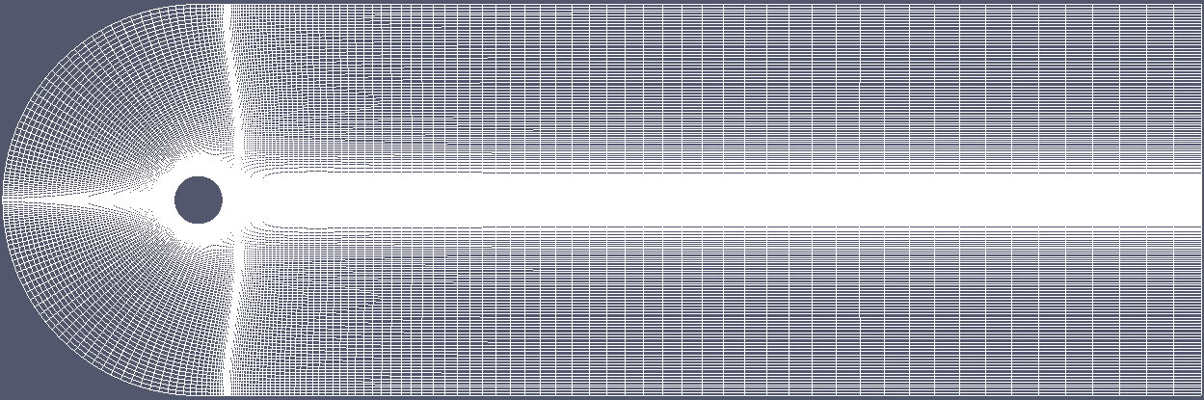

The upstream boundary is a circular arc of radius 4*D, where D is the cylinder diameter. The downstream boundary is placed 20 diameters away from the cylinder.   
  
The simulation was performed with a compressible flow solver, run at low Mach number. Although this is not an ideal match for the ocean, it is the only code readily available in the Boulder Office which can perform this type of simulation. It turns out that the computational timestep is proportional to the Mach number. Thus running at very low Mach number would imply a very small timestep and hence a very large number of time steps (requiring a large amount of computer time). Although one would like to choose a very low Mach number in order to minimize compressible effects, a compromise must be made in order to keep the computational time reasonable. In this case, a free-stream Mach number of 0.15 was chosen. According to the isentropic relation, the density varies by 1.2% between the free-stream and the stagnation point at this Mach number. Thus compressible effects are not expected to play a significant role in this simulation. While the full-scale island flow will have a Reynolds number of order 10^9, it is not possible to simulate such a high value. Fortunately the overall flow topology is reasonably insensitive to Reynolds number within a given Reynolds number regime. The island wake case falls into the post-critical turbulent boundary layer regime, which begins at about Re=10^6. Although attainable, rather high resolution is required in order to simulate Re=10^6. Thus in this initial simulation, the Reynolds number is reduced further to Re=10^3. Although this seems like a drastic reduction, it merely moves the flow into an adjacent Reynolds number regime which is qualitatively similar. The main distinction is that the cylinder boundary layers should be turbulent instead of laminar, and there should be increased three-dimensional structure in the wake. We are not able to capture 3D structure with this simulation in any case, so the main difference lies in the boundary layer structure. The higher Reynolds number turbulent boundary layers tend to separate further aft as compared to the laminar boundary layers simulated here. In reality the delayed separation will lead to a near wake that is more narrow than the current simulation.   
  
Since the flow is treated as being very weakly compressible, we can use the temperature field as a nearly passive tracer. This is convenient for flow visualization purposes. The animation below shows the evolution of the wake flow, using the temperature field as a tracer. Friction within the cylinder boundary layers results in a ~3 degree increase in the fluid temperature. This warmer boundary layer fluid naturally finds its way into the wake vortical structures. The animation below shows the time evolution of the wake formation.   
  
The simulation was started from rest and the flow was then ramped up to the desired speed U over a period of D/U. Time shown in the animation is normalized via t*=Ut/D.   
  
Boundary layer separation first occurs at about t*=2. Reasonably symmetric vortex shedding then exists out to a time of about t*=20. The shedding then becomes asymmetric and remains that way for the duration of the simulation.

## Temperature 'dye' tracer - Click on the image to start the the movie

[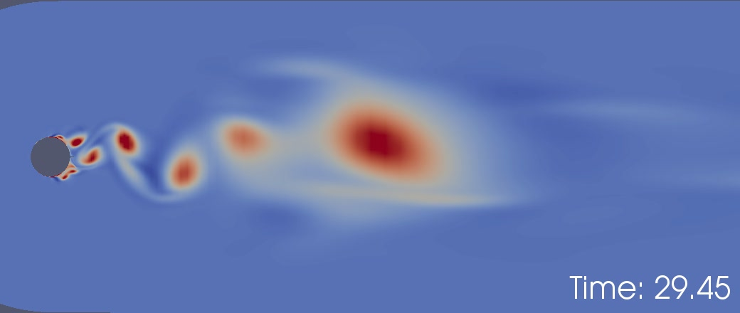](IslandWake01.avi)

Although the resolution is probably adequate near the cylinder, the mesh becomes too coarse within a few cylinder diameters downstream. This is why the vortex structures seem to diffuse near the downstream section of the domain. The resolution will be increased in the next simulation.