VIPER 3.0 - A Vortex Diffusion Based Aircraft Wake Model

**Thomas S. Lund**

**Northwest Research Associates**

**CoRA Office**

**3380 Mitchell Lane, Boulder, CO 80301**

**3/8/2016**

## 1 Coordinate System and Basic Assumptions

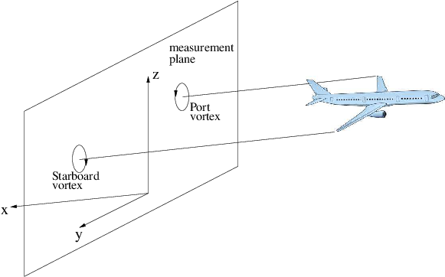

Figure 1: Aircraft vortex wake and the coordinate system used to describe it.

Our objective is to predict the time evolution of an aircraft vortex wake as observed in an earth-fixed frame. Figure illustrates the situation where an aircraft passes through the fixed *y*-*z* measurement plane at time *t*=0. As time goes on, the vortices contained in the measurement plane decay in strength and generally descend towards the ground. They may also advect laterally due to a crosswind.

Like nearly all prior vortex wake models, we idealize the flow as being contained to the measurement plane (i.e. two-dimensional). This idealization precludes any axial flow within the vortex system and also precludes any associated axial mass, momentum, or energy transport. The effects of a headwind are accounted for directly by varying the vortex release points (in *x* and *z*) at each time step so that the vortices advect back to the measurement plane exactly at each model output time.

In addition to the effects of winds noted above, the model will also account for the effects of stable stratification, ambient turbulence, and for crosswind shear gradients.

## 2 Vortex Diffusion

### 2.1 Experimental Observations

The starting point for our vortex wake model is a simple description for the decay of the two wing tip vortices. Experimentally[, , , ] it is found that the flow within each vortex is very nearly axisymmetric and obeys the following simple azimuthal velocity distribution, known as the Burnham-Hallock (BH) profile:

(1)

where *r* is the radial coordinate, *R* is the vortex core radius and is the circulation that would be achieved if the profile remained valid all the way out to . In reality the BH profile is only valid for small to moderate values of the non-dimensional distance *r*/*R*, since the flowfields due to the two vortices will interfere near the plane of symmetry between them. The range of validity of Eq. () can be estimated by noting that, for an elliptically-loaded wing, the distance between the two trailing vortices () is , where *B* is the aircraft wingspan. Although there is quite some scatter in the measurements, aircraft wake core sizes have been estimated to be between 0.01*B*-0.06*B*[, , ]. By taking and *R*≃0.03*B*, we find . This is admittedly a very crude estimate, given the uncertainty in the vortex core size. It is probably better to assume the profile is strictly valid out to *r*/*R*=6, probably valid out to *r*/*R*=10, and then questionable for larger *r*/*R*.

An important second finding from the aircraft wake field measurements is that the vortex core size changes only slightly over the course of the wake decay. This is in stark contrast to Lamb’s analytic solution for laminar vortex decay, which predicts a significant increase in the core radius as the vortex decays. The contemporary understanding of this disparity is that aircraft wake vortices are turbulent with effective transport coefficients that depend strongly on *r*. The solid-body rotation near the vortex core inhibits turbulent transport within this region. Turbulence becomes much more effective outside of the core and thus we can think of the turbulent vortex as being eaten away from the outside, leaving the core largely intact.

### 2.2 Plan of Attack

While the behavior of of aircraft wake vortices within the limited axisymmetric region near each core are fairly well understood, we are faced with the significantly more difficult task of modeling the behavior of the entire vortex system, including the strongly non-axisymmetric interaction between the two vortices. Given the complexity this problem, we proceed in a step by step manner, building from the insights provided by the vortex field measurements. Our approach involves the four following key steps: (1) develop an analytic solution for the effective eddy viscosity distribution necessary to match the vortex decay field measurements, (2) extend this solution in a logical way outside of the axisymmetric regions and use the resulting eddy viscosity distribution in a high-resolution numerical simulation of a vortex pair decay, (3) abstract key features of the numerical simulation results into a simple model of the aircraft vortex wake system, (4) tune the resulting model against aircraft landing data so that it accounts properly for the effects of winds, ambient turbulence, and ambient stratification.

## 3 Axisymmetric Turbulent Vortex Diffusion

The objective of this section is to develop an analytic solution for the eddy viscosity distribution necessary to reproduce the aircraft vortex decay measurements. We begin with a review of the key kinematic relations and the conservation laws.

Consider a time-dependent, axisymmetric, incompressible swirling flow where , , and . For this simple flow the vorticity reduces to a single component given by

(2)

The Circulation around a circular contour of radius *r* is

(3)

The mass conservation and axial momentum equations are satisfied identically. The radial and azimuthal momentum equations reduce to

(4)

(5)

where is the viscous stress, which is given by

(6)

Here we expect the flow to be turbulent and thus is the Reynolds averaged velocity and is the sum of the molecular and eddy viscosity, with the latter being a function of the radial coordinate.

By making use of the above definition of the stress it is possible to write the azimuthal momentum equation () in the following useful alternative form

(7)

An evolution equation for the vorticity can be derived from this equation by making use of Eq. ()

(8)

Equations () and () can be combined to yield the following evolution equation for the circulation

(9)

We start the analysis by requiring that velocity profile obey Eq. () with *R* fixed but variable in time. Equations (), () and () then give the following expressions for the velocity time derivative, the vorticity, its radial derivative, and the shear stress

(10)

(11)

(12)

(13)

If Eqs. ()-() are substituted into Eq. () and the result simplified, the following equation for the eddy viscosity arises

(14)

The solution to Eq. () is

(15)

where the meaning of the parameter τ will become apparent in a moment. The above solution is interesting in that it takes the form of the product between a universal function of *r* and a scaling function of time, with the latter being related to the circulation decay. For short to intermediate times, the circulation decay is well-described by the linear decay law

(16)

where is the initial circulation and τ is the time required to drive the circulation to zero. The linear decay is typically valid up to 3-4 non-dimensional time units, , where is the initial vortex descent velocity. For reference, .

The linear circulation decay law results in the following time scaling function

(17)

This is an increasing function of time that diverges when *t*=τ (which is well beyond the range of validity for the linear decay model). For small to moderate times, the growth in the scaling function is modest, maximizing at 1.67 times the initial value when . Thus the analytic model predicts a slight growth in the eddy viscosity for small to intermediate times. This is plausible since the turbulence is becoming established during this time period.

For later times it is reasonable to expect that the eddy viscosity transitions first to a time-independent steady state, and then perhaps a decaying final state. A steady-state eddy viscosity requires an exponential circulation decay of the form

(18)

This function is constructed such that the value and slope match the linear decay law at . To summarize, we consider the following composite circulation history

(19)

which gives rise to the following composite time scaling functions

(20)

The universal function of *r* in Eq. () is somewhat complicated in form. The behavior of this function is much more readily apparent if the following matched asymptotic approximation is used

(21)

This approximation is exact in both limits and and is a fairly good approximation in between. Its accuracy at intermediate *r* can be increased at the expense of some asymptotic error at by taking the parameter α away from 1 slightly. Figure shows a comparison of the exact and approximate solutions for α=0.975, , , , *t*=0, and standard atmospheric conditions.

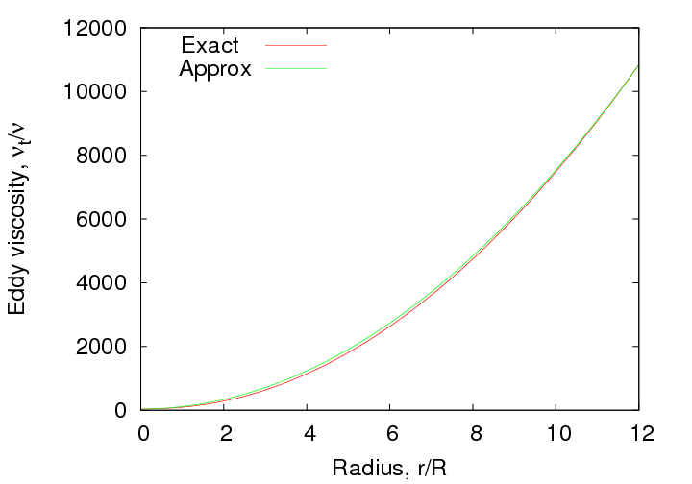

Figure 2: Comparison of the exact and approximate solutions for the eddy viscosity radial dependence. The eddy viscosity is normalized by the molecular viscosity. The solutions were generated for , and standard atmospheric conditions.

As anticipated, the eddy viscosity is small at the origin and increases with radius (like ). This is consistent with the picture of weak turbulence within the core and increased turbulent transport outside of the core.

### 3.1 Extension of the Eddy Viscosity Distribution

The analysis of the preceding section indicates that a physically-plausible eddy viscosity distribution exists that will reproduce the experimentally-observed adherence to the Burnham-Hallock velocity profile with fixed core radius as the wing-tip vortices decay. One important limitation of this solution is that it is valid only within a limited radial extent (up to  r/R=10 say) around each vortex. Thus, by itself, Eq. () is not sufficient to produce a solution for the entire vortex wake flow field. In order to circumvent this difficulty, we extend Eq. () in a logical way for larger radii and also account for the interaction of the two vortices near the plane of symmetry between them.

The first step in generalizing the eddy viscosity distribution is to recognize that the dependence predicted by Eq. () at large *r* must be modified significantly so that as . Although it is somewhat arbitrary, one way to achieve this goal is to multiply Eq. () by the following radial damping function

(22)

where is the centroid for the damping distribution and *d* is a measure of its width. Values for these parameters were determined via an iterative process where trial values were used in somewhat coarse simulations of a B747 vortex pair evolution (as discussed in the following section). Too small a value for and/or too large a value for *d* was found to result in deviations from the BH profile over its assumed range of validity. Similarly too large a value for and/or too small a value for *d* was found to result in a vortex descent rate that was not in acceptable agreement with the field measurements. The exploratory simulations yielded values of , .

An eddy viscosity distribution for the entire vortex wake system was constructed by superimposing the damped radial distributions from the two vortices using a special non-overlapping summation where the eddy viscosity at any field point is simply equal to the value due to the closest vortex. The composite eddy viscosity distribution is shown in Figure .

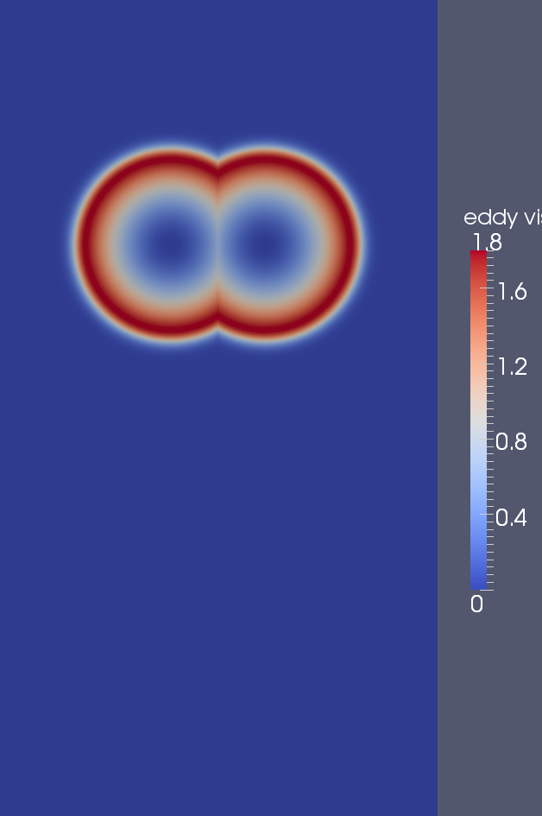

Figure 3: Composite eddy viscosity distribution for an aircraft vortex wake.

It should be stressed that the accuracy of the assumed eddy viscosity damping or the superposition procedure is not critical in the success of the numerical simulations. The main objective of the simulations is to study the overall behavior of the wake system so that it can be abstracted into a simple mathematical model. The resulting model will contain tunable constants that will be adjusted to match actual aircraft vortex wake measurements. Small errors in the numerical simulations can be accounted for at this stage.

## 4 Numerical Simulations

The simulations target a B747 wake with initial vortex spacing of =46 m, an initial altitude of 279 m, an initial circulation of =550 /s, and an initial vortex core radius of *R*=2 m. Our choice for core size is very close to 3% of wingspan, which puts it in the range of the measurements taken by Burnham and Hallock[, ]

The initial velocity field is simply the superposition of two Burnham-Hallock vortices.

The simulations were performed on a computational domain extending from the surface to 576 m in altitude (z direction), and spanning 960 m in the horizontal (y) direction. A grid with Nx=2400, Nz=1440 was used so that the mesh spacing is 0.4 m in both directions. The mesh spacing to initial vortex core radius is Δ*x*/*R*=Δ*z*/*R*=0.2. Slip walls were used at the top and bottom, whereas periodic boundary conditions were used in the horizontal directions. The slip wall condition at the top and the periodic conditions in the horizontal are slightly problematic in that they imply the presence of non-physical image vortices. However, the effect of the image vortices was minimized by making the domain much larger than the minimal dimensions required to resolve the primary vortices. In order to study the effects of buoyancy and crosswind shear gradients, three simulations were performed, one with a neutral atmosphere and no crosswind, a second with an isothermal (stable) atmosphere and no crosswind, and a third with a neutral atmosphere and a quadratic variation in crosswind with altitude.

In order to keep the simulations simple, the eddy viscosity distribution was held fixed in time. This situation corresponds to a pure exponential circulation decay, as given by Eq. () with .

While the basic shape of the eddy viscosity distribution is fixed in time, it translates with the vortex pair as it descends. To do this, the vortex cores are tracked in time by finding the two locations of minimum pressure.

As mentioned above, simulations were performed with and without stable stratification. Case 1 uses a temperature lapse rate of -9.77 K/km, which produces a neutral (unstratified) atmosphere. Case 2 uses an isothermal atmosphere with temperature T=300k. This gives a buoyancy period of 352 seconds, or equivalently 5.9 minutes. Circulation time histories from the two simulations, (computed on a circle of radius 15 m), are shown in Figure .

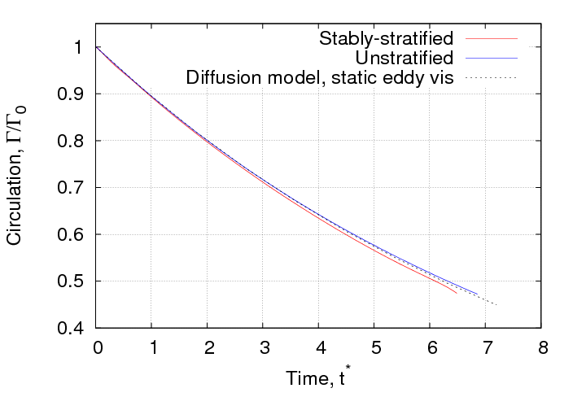

Figure 4: Circulation time histories from the numerical simulations compared with the expected decay law.

The circulation time histories from the two simulations are rather similar. The unstratified case is in almost perfect agreement with the expected exponential decay law, whereas the stratified case decays slightly faster. These results seem to suggest that the simple axisymmetric diffusion model for a single vortex is surprisingly accurate when modified via a damping function and applied to the non axisymmetric flow in a vortex pair.

Similar to the circulation decay, the simulations produces velocity profiles that look very much like what is found in experimental data. Figure shows a comparison of the initial Burnham-Hallock profile and the profile taken from the unstratified simulation at t=100 s.

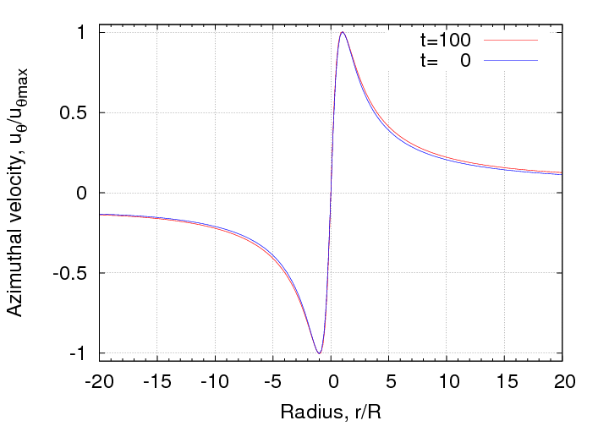

Figure 5: Azimuthal velocity profiles from the numerical unstratified numerical solution.

The vortex core size is seen to remain fixed and the overall profile shape remains rather close to the Burnham-Hallock initial condition.

## 5 Model Elements based on Insights from the Numerical Simulations

### 5.1 Fate of the Diffused Vorticity

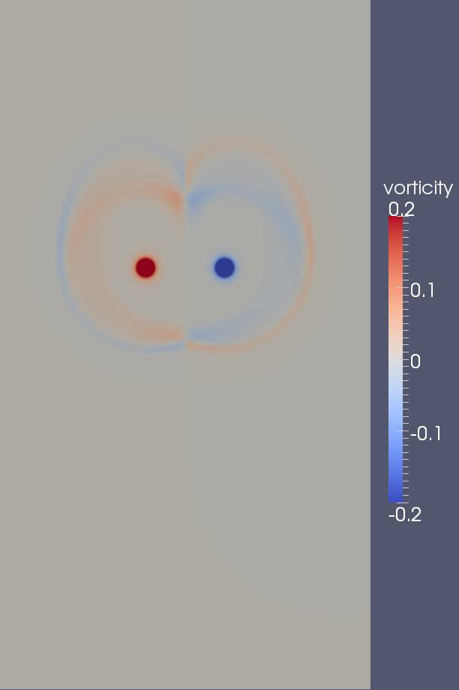 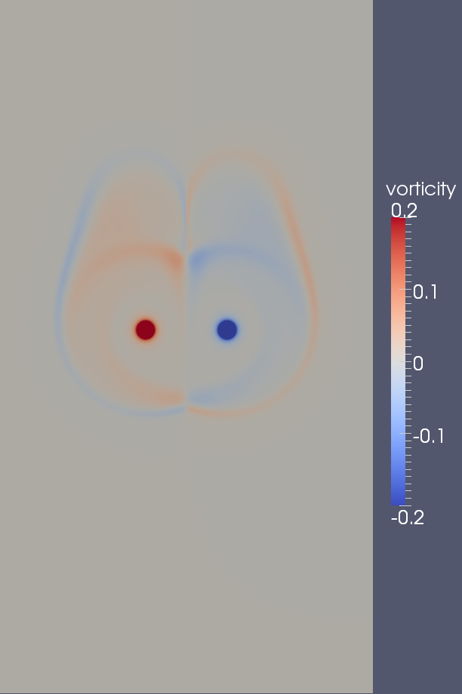

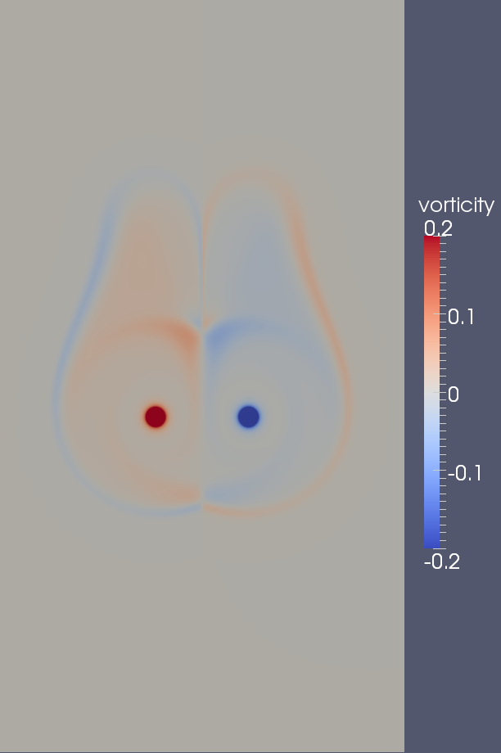 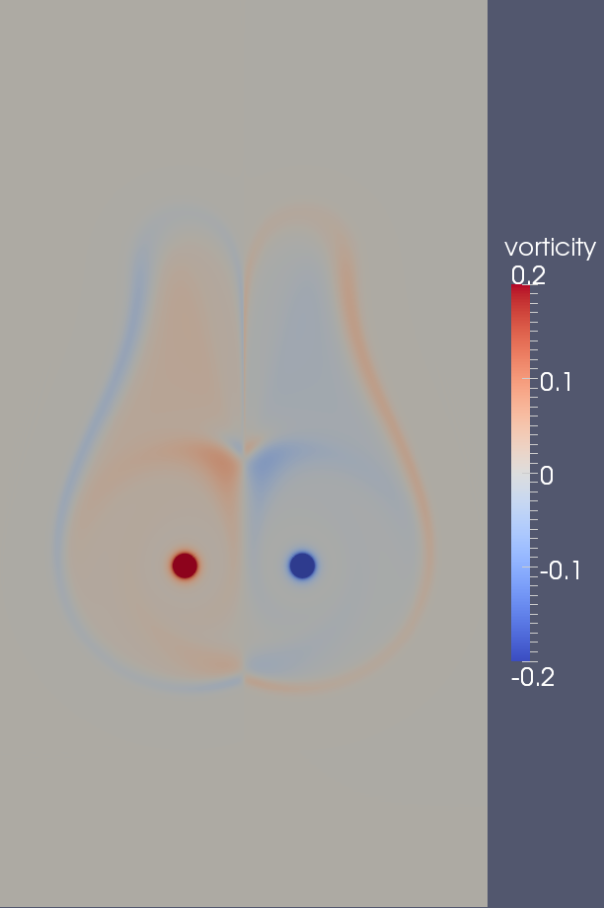

Figure 6: Vorticity contours from the unstratified simulation. From top left to bottom right the images are taken at 20, 40, 60, and 80 seconds.

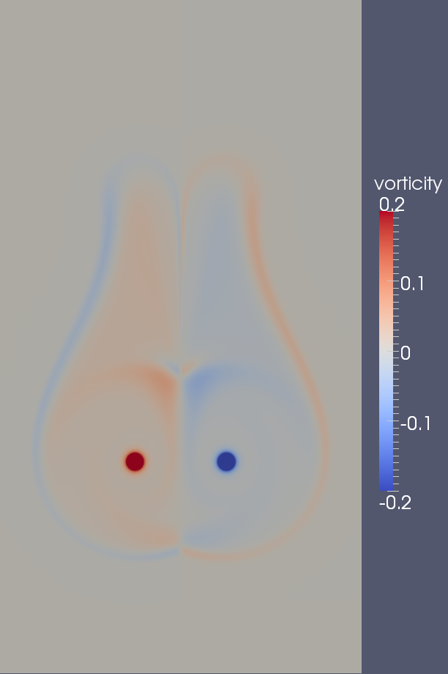 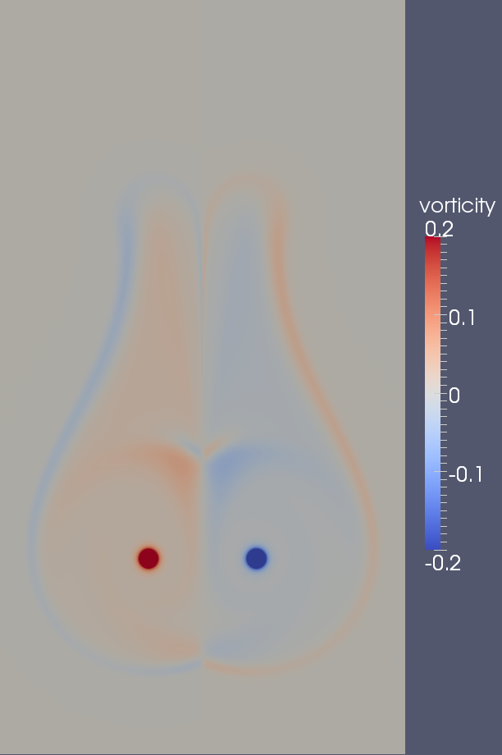

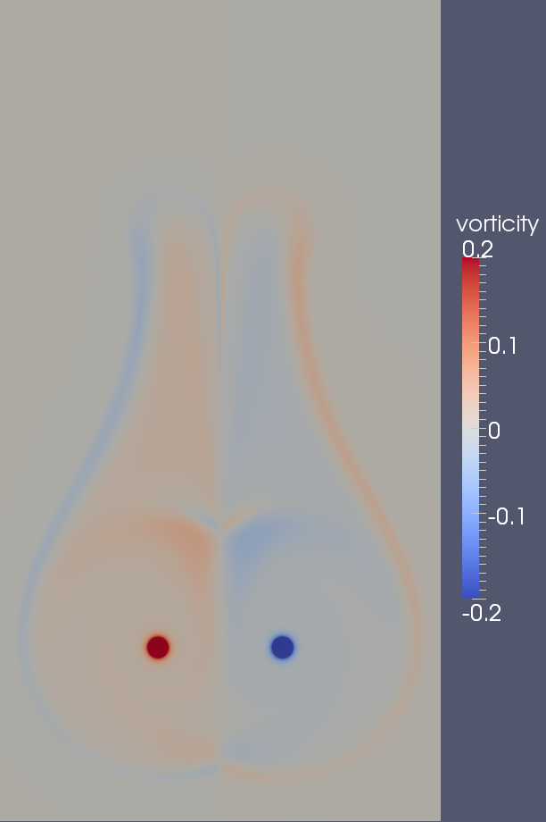 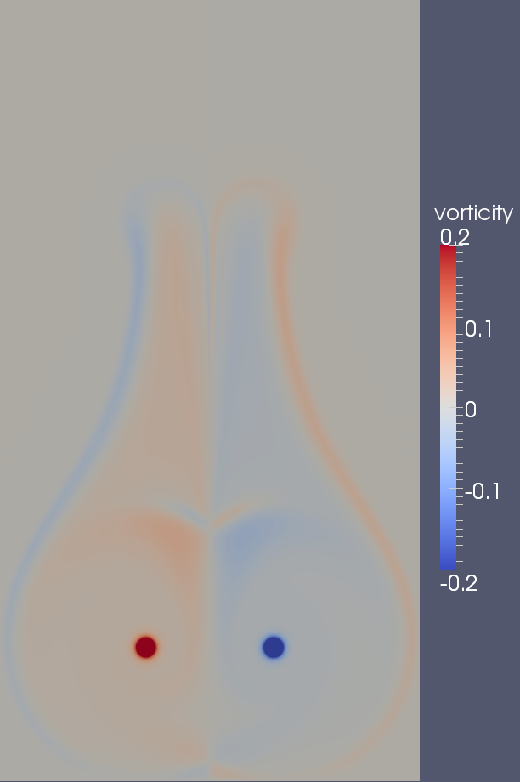

Figure 7: Vorticity contours. From top left to bottom right the images are taken at 100, 120, 140, and 160 seconds.

The main objective of the numerical simulations is to determine the far-field vorticity distribution, i.e. well beyond the maximum range of validity of the analytic model. The far-field vorticity distribution is difficult to predict as it is directly affected by the lingering diffusion in the damped region, advection caused by vortex induction, and mutual destruction in the overlap region near the plane of symmetry. Considerable insight to these complex processes can be gained through a time sequence of vorticity contour images. Such a sequence, taken at 20 sec. intervals, are shown in Figures and .

Starting with the upper left panel in Figure (at t=20 sec.) we see an expected deposition of vorticity in a band corresponding to the region where the eddy viscosity damping becomes significant. We also see a perhaps unexpected thin band of counter-sign vorticity outside of the primary band. This band is caused by a vorticity source term arising from radial gradients in the eddy viscosity. Counter sign vorticity is generated when the eddy viscosity decreases with radius. This effect is perhaps most apparent from the last term in Eq. (). In what follows we shall refer to the far-field vorticity distribution as the "halo" since it more or less encircles the primary vortex.

Another striking feature of the vorticity image at t=20 sec. is that there is virtually no diffused vorticity present along the plane of symmetry between the two vortices. This is evidence of mutual destruction as vorticity of opposite sign diffuses together in the interaction zone between the vortices.

Moving to the top right frame in Figure (at t=40 sec.) we start to see the effects of advection as the vortex pair (and its associated) oval descend vertically downward. Vorticity existing outside of the oval is left behind, giving the distribution a more pear-like appearance. The pear shape is even more apparent at t=60 sec (middle left frame in Figure ). We also begin to see a penetration of primary vorticity near the symmetry line. This effect is due to advection along "D" shaped streamlines within the vortex oval. This effect continually transports a fresh supply of vorticity along either side of the symmetry line. Some this vorticity is destroyed due to mutual diffusion, but a fraction survives, especially for the region inboard of the symmetry line.

The vorticity distribution progresses in a logical way for the remainder of the images in Figures and . In particular, the basic distribution becomes more elongated, and the bands of primary vorticity continue to penetrate a bit deeper along the symmetry line.

### 5.2 Modeling the Net Effect of the Far-Field Vorticity Distribution

From a theoretical standpoint, the motions of each of the two primary vortices can be determined exactly via application of the Biot-Savart law to the entire vortex field. Of course such detailed information will not be available in a fast wake model and thus our objective here is to use the numerical simulation data in order to approximate the far-field vorticity distribution in a simple way that produces similar net induction on the primary vortices. A good way to think about this process is that we would like to merge or "condense" the far field "vorticity halo" into a small number of discrete "halo" vortices.

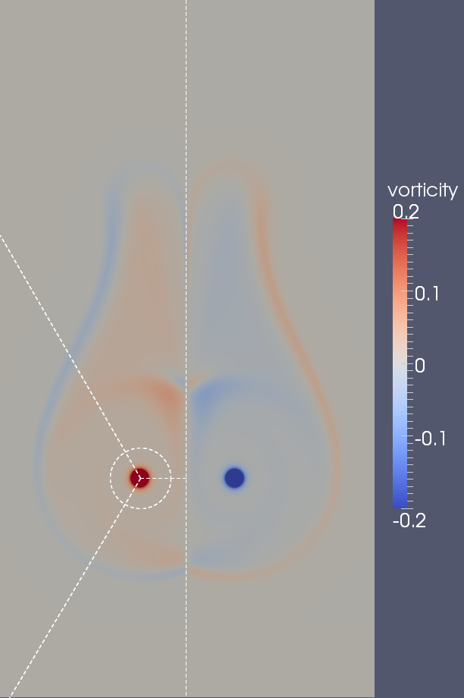

Figure 8: Division of the flow field into three distinct regions for each side of the vortex wake. The division is shown only for the left half.

The procedure for determining the strength and position of the halo vortices is actually quite simple. We start by dividing each half of the field into three equi-angular () quadrants as illustrated for the left half of the field in Figure . We then draw a circle of 15 m radius around the primary vortex. The area inside this circle is used to compute the circulation and induction due to the primary vortex and is thus excluded from the halo field computation. Next, for each sector (outside the 15 m radius circle), we compute the net circulation as well as the net induced velocity at the position of the primary vortex. Finally we iteratively solve a small non-linear problem to determine the *y* and *z* coordinates for an effective concentrated vortex having the same circulation and the same induced velocity on the primary vortex as determined for the entire sector. This procedure is repeated for each of the 160 output times available from the simulation.

While the above procedure could be applied to each half of the flow field independently, our numerical simulations were constructed to be anti-symmetric with respect to the symmetry line. Thus for present purposes it is sufficient to consider only the left (port) half of the flow field. Thus in what follows we develop procedures for determining the strength and position of just the three halo vortices on the port side. The strengths and positions of the halo vortices on the starboard side then follows by symmetry.

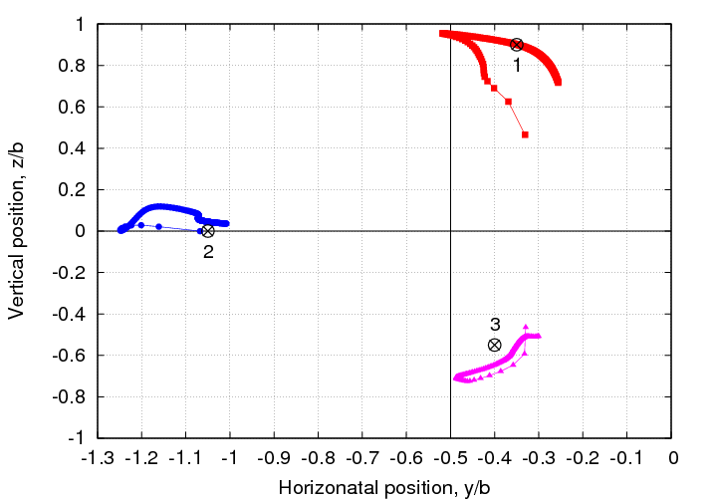

Figure 9: Effective concentrated vortex positions computed at each output time from the unstratified simulation. The black center mark symbols indicate the chosen fixed position for each vortex and these are numbered moving counterclockwise from the upper right as indicated. The primary vortex is located at *y*/*b*=−0.5, *z*/*b*=0 (the intersection of the solid black lines).

The end result of the halo vorticity data reduction exercise is a time sequence of halo vortex positions and circulations for each of the three sectors on the port side. As one might expect, the positions of the halo vortices are not fixed in time. This effect is illustrated in Figure where the port side halo vortex positions for each of the 160 output time instants are plotted. For each sector, the vortices move quickly for several steps near *t*=0 (the end of the trace where the symbols are widely spaced) and then settle in to a more regular trajectory. Although there is some tendency for each of the vortices to converge to a fixed location, this is not really achieved. Since we would like the fast wake model to be as simple as possible, it was decided to ignore the motions of the halo vortices. As will be demonstrated below, the vortex motion is evidently not a critical detail in the overall accuracy of the model and very good results can be obtained using static halo vortex positions.

At the outset, we determined the halo vortex positions by simply averaging their position data in time. Later we found that slightly better results could be obtained by adjusting the vortex positions slightly from the average location. The final chosen static positions are indicated by the black center mark symbols in Figure and their coordinates are listed in Table .

|  |  |  |  |  |  |
| --- | --- | --- | --- | --- | --- |
|  | |  | |  | |
| *y*/*b* | *z*/*b* | *y*/*b* | *z*/*b* | *y*/*b* | *z*/*b* |
| -0.35 | 0.90 | -1.05 | 0.0 | -0.40 | -0.55 |

Table 1: Fixed positions for the halo vortices.

It is useful to understand how each of the halo vortices influences the motion of the primary vortex. Since we are considering the port side, all of the vortex circulations are clockwise. The halo vortex along the *y* axis (blue symbols in Figure ) induces a strictly downward velocity on the port primary vortex. It also induces a smaller, strictly downward velocity on the starboard primary vortex. The halo vortex above the *y* axis (red symbols in Figure ) induces a flow up and to the left at the position of the port vortex. It also induces a weaker flow downward and to the left at the position of the starboard vortex. Finally the halo vortex below the *y* axis induces a flow upward and to the right on the port vortex and a weaker flow downward and to the right on the starboard vortex. The upshot of all of this is that the lateral motion of the primary vortices is controlled by the two halo vortices above and below the *y* axis, whereas the vertical motion is largely controlled the vortex on the *y* axis.

With the positions of the halo vortices determined, the next task is to specify how their circulations change in time. We accomplish this in a two-step procedure where the total halo circulation is estimated first and then this circulation is partitioned among the three halo vortices.

If it were not for the mutual destruction of circulation near the symmetry line, the total circulation contained on each half plane would be constant in time in an unstratified environment. Instead of attempting to model the rate of circulation destruction, we turn instead to the following simple ansatz that considers the lost circulation to be proportional to the total available circulation in the halo

(23)

where is the primary vortex circulation computed about the 15 m circle and *F*(*t*) is an attenuation function that accounts for circulation destruction near the symmetry line. If F(t)=0, no circulation is lost. Similarly if *F*(*t*)=0.5 then half the available circulation is lost to destruction along the symmetry line.

The numerical simulation data showed the attenuation function to be a nice smooth function that is well approximated by the following simple quadratic form

(24)

where is the non-dimensional time. The success of this fit is demonstrated in Figure .

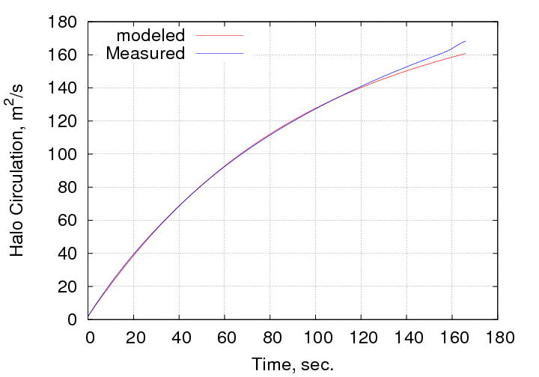

Figure 10: Comparison of estimated and measured total halo circulation for the unstratified simulation.

With an estimate of the total halo circulation in hand, the only remaining detail is to prescribe how this circulation is partitioned among the three halo vortices on each side of the wake oval. Since the sum of the three vortex circulations is known, it is only necessary to predict circulation levels for two of them. We choose to estimate the strengths of vortices 1 and 2 in Figure and these are well represented by hyperbolic tangent interpolants of the following form

(25)

where , , , and , *i*=1,2 are fit constants to be determined. The hyperbolic tangent fits simply transition the partition fraction from a value of at *t*=0 to a value of at , over a time of , centered at time .

The partition fractions are used in the following logical way

(26)

The parameters in the partition fraction fits were determined via regression against the numerical simulation data. This would be straightforward if it were not for the fact that we have chosen to used fixed positions for the halo vortices. The halo vortex circulation values determined in the data analysis discussed above were computed in conjunction with variable halo vortex positions, and thus are really not appropriate for an approximate system having vortices of fixed-position. In order to rectify this disparity, the data analysis was repeated. In the modified analysis, the halo vortex partition fractions were solved for using fixed vortex positions. Physically, this amounts to allowing the sector boundaries to move at each time step so that the net induction of the three fixed halo vortices matches the induction of the entire far-field at the position of the primary vortex. While this step does not fundamentally change the behavior of the partition functions, it makes these much more consistent with the fixed-position halo vortices.

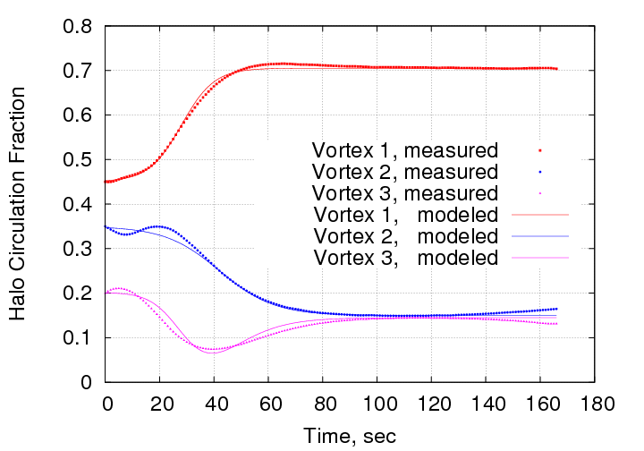

Figure 11: Curve fit of the halo vortex circulation partition fractions compared against measurements taken from the unstratified numerical simulation. These fits are for =0.45, 0.71, =1.16, , =0.35, 0.15, =1.74, .

The hyperbolic tangent fits were optimized against the modified partition fraction measurements and the net result is shown in Figure . While these fits do not capture the oscillations present for *t*<40 sec., they do a reasonable job of fitting the remainder of the profile details. Errors for small times are not a large concern since the halo vortex strengths are low during this time (see Figure ) and thus these vortices have only a small influence on the motion of the primary vortices.

### 5.3 Construction of the Fast Wake Model

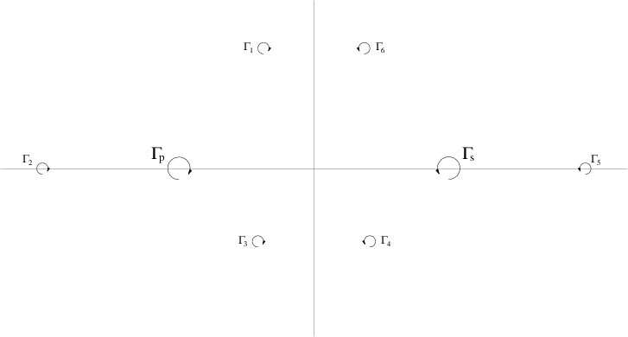

Figure 12: Composite vortex system for the fast wake model.

All of the pieces required for the fast wake model are now in place. The decay of the primary vortices is given in the form of Eq. () (with replaced by and ), and the strengths of the fixed-position halo vortices are determined via Eqs. ()-(). The motions of the port and starboard primary vortices are then computed by considering the net induction from all of the vortices in the system. As shown in Figure there are a total of 8 vortices, the port and starboard primaries and six halo vortices, three for each half of the wake system. We also consider a mirror image system of the 8 vortices below the ground in order to model the effect of the ground plane. When considering the ground plane image system, the total induced velocity at the position (*y*,*z*) is

(27)

where (,), *i*=1,8 are the positions of the 8 vortices. Note that when the induction is computed at the position of one of the primary vortices, the terms corresponding to the vortex induction on itself take the indeterminate form 0/0. Since a 2D vortex induces no velocity at its center, the correct resolution of the indeterminate form is 0. This case is treated with a logic statement in the computer code.

In order to obtain a numerical solution for the primary vortex circulation decay and primary vortex trajectory, we cast the problem as a system of first order differential equations that can be integrated forward in time using standard algorithms. Thus we use the primary circulation decay specification in the form of Eq. () (with replaced with and ) together with the kinematic relations , , , . We use a flexible Runge-Kutta algorithm for the time advancement that can be set to any desired order of accuracy. Currently we use the second order variant.

Although we generally begin with symmetric initial conditions (, , ), the solution procedure is set up to allow for asymmetric situations. These can either arise due to asymmetric initial conditions or asymmetric decay in the primary vortices (due to crosswind shear gradients, for example). In the case of an asymmetric situation, the halo vortices retain their positions as listed in Table , but these are now measured in a local coordinate system defined by the two primary vortices. The strengths of the halo vortices are computed independently for each half of the wake system, using the corresponding value of the primary vortex circulation. Other than these details, no other changes are required in the solution procedure.

### 5.4 Initial Validation of the Fast Wake Model

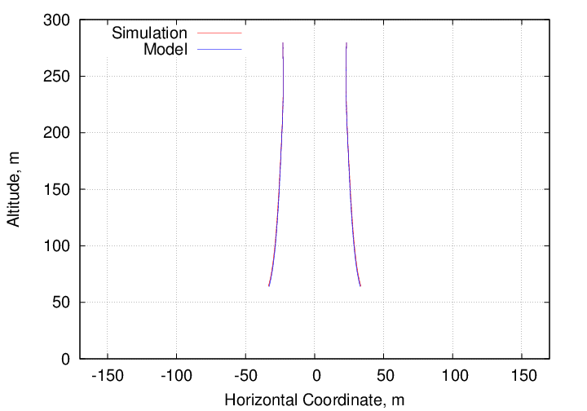

Figure 13: Vortex trajectory computed by the fast wake model compared with the numerical simulation.

The first step in the model validation is to ensure that it can accurately reproduce the numerical simulation from which it was constructed. While this may seem like a unnecessary step, several approximations have been made in the construction of the model. These have do do with the halo vortex positions, as well as their circulation time histories. It is thus important to assess the impact of these approximations. There is no need to check the primary vortex circulation decay as these are simply inputs to both the fast wake model and to the numerical simulations (see Figure ).

Results of the model/numerical simulation comparison for the vortex trajectories are shown in Figure . The agreement is surprisingly good, showing no visible difference between the model prediction and the simulation data. This result is significant since it indicates that the approximations made in modeling the positions and strengths of the halo vortices have almost no bearing on the accuracy of the computed trajectory.

### 5.5 Initial Validation/Tuning against Aircraft Landing Data

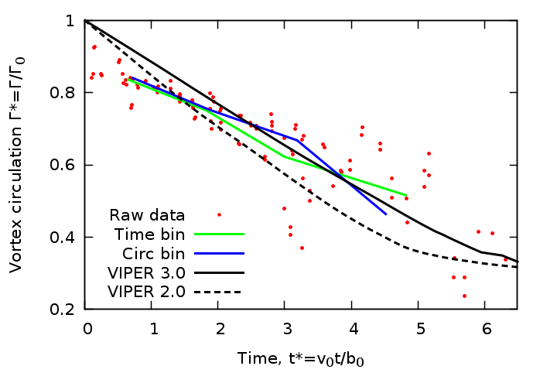

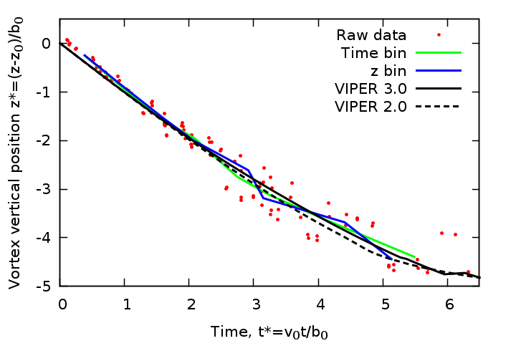

Figure 14: Comparison of the model prediction against the baseline landing data that have low turbulence, stratification, and crosswind shear gradient.

The next step in the model validation/tuning process is to compare it against aircraft landing data. We chose the Frankfurt 2004 landing data set since it seems to have the most believable circulation measurements. We begin this exercise by considering those cases that have simultaneously low ambient turbulence, low stable stratification, and low crosswind shear gradient. There are 7 of these ’baseline’ cases that have benign environmental conditions. Rather than compare the model prediction with each case independently, we average the non-dimensional predictions for the individual cases and compare with this with the field measurements for all of the cases. This step greatly enhances the sample of measurement values and simplifies the validation/tuning process since it is only necessary to consider two plots, one for the primary vortex circulation and one for the vortex vertical trajectory.

|  |  |  |  |
| --- | --- | --- | --- |
|  |  |  |  |
| 0.45 | 0.54 | 1.16 | 1.24 |

|  |  |  |  |
| --- | --- | --- | --- |
|  |  |  |  |
| 0.35 | 0.15 | 1.74 | 2.07 |

Table 2: Curve fit coefficients for Eq. ().

Comparison of the model prediction with the baseline landing data for the circulation decay parameters , is shown in Figure . The agreement is seen to be quite good for both the circulation decay and the vortex vertical trajectory. In order to obtain these results, it was necessary to make a slight adjustment to the parameters used to specify the halo vortex circulation partition fractions (Eq. ()). In particular, the parameter that specify the fraction of halo circulation assigned to vortex 1 at needed to be adjusted slightly. The adjusted values (together with those that were not changed) are listed in Table . These values have worked well for all other landing data comparisons (discussed below) and thus appear to be universal values for actual aircraft landing data.

Although the reason behind the need to change the one halo circulation partition parameters is not entirely clear, it is likely due to inaccuracies in the assumed damping function applied to the eddy viscosity distribution and/or the effects of the somewhat artificial boundary conditions used in the numerical simulation. The fact that the adjusted halo circulation partition fraction values appear to be universal for at least the Frankfurt 2004 landing data helps to substantiate the claim that small errors in the numerical simulation could be corrected for in the fast wake model via adjustments of a few key parameter values.

### 5.6 Tuning for the Effects of Ambient Turbulence

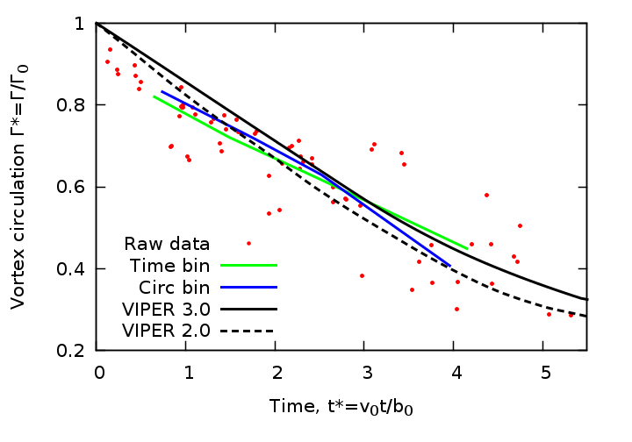

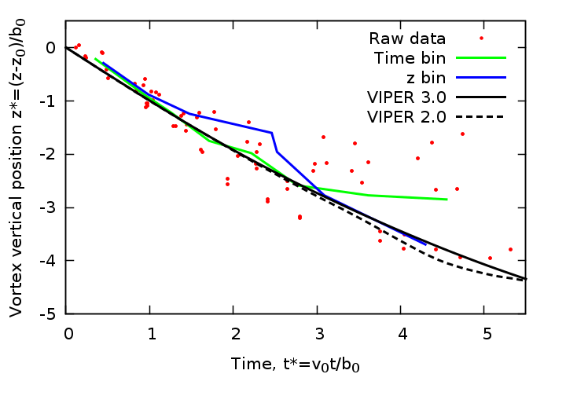

Figure 15: Comparison of the model prediction against the moderate turbulence landing data.

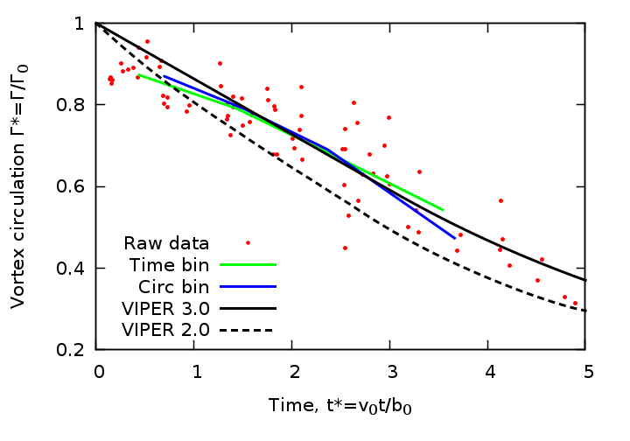

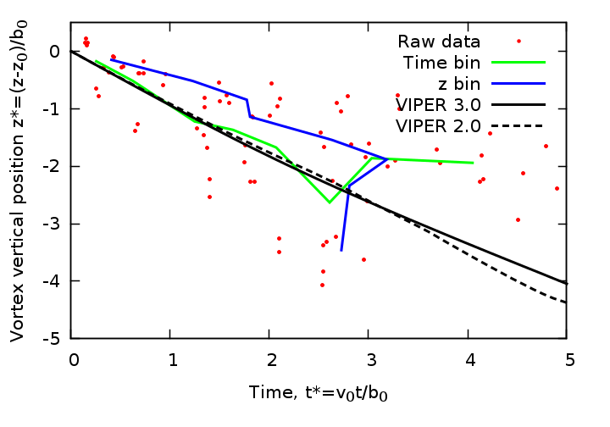

Figure 16: Comparison of the model prediction against the high turbulence landing data.

The main effect of increasing ambient turbulence is to increase the rate of circulation decay. Using an iterative tuning exercise with the landing data grouped for both moderate and strong ambient turbulence, we found that the effects of turbulence could be accounted for rather completely via the following simple adjustment to the primary circulation decay parameter τ

(28)

where is the non-dimensional ambient eddy dissipation rate. Results using this tuning are shown in Figures and . While there is less data as opposed to the baseline cases, and there is more scatter, the model prediction is seen to be quite good.

### 5.7 Incorporating the Effect of Stable Stratification

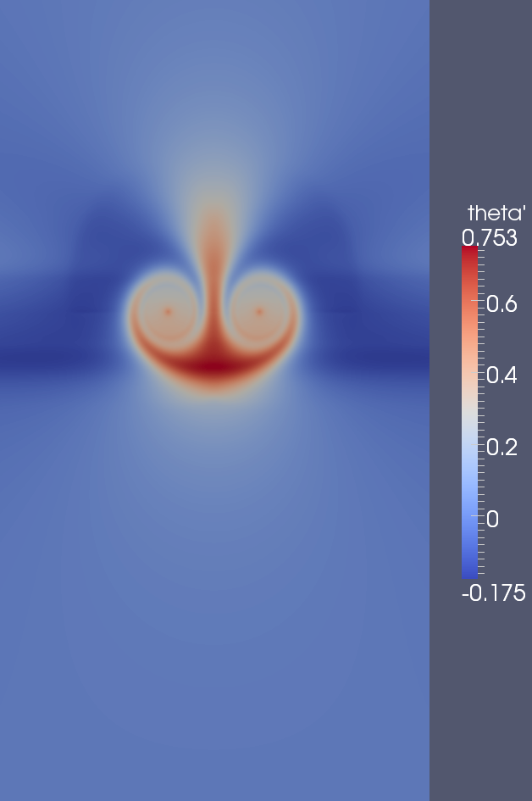 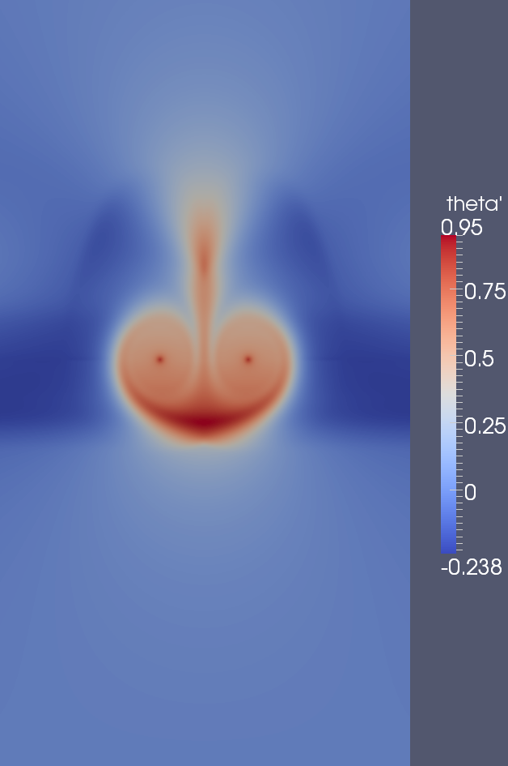

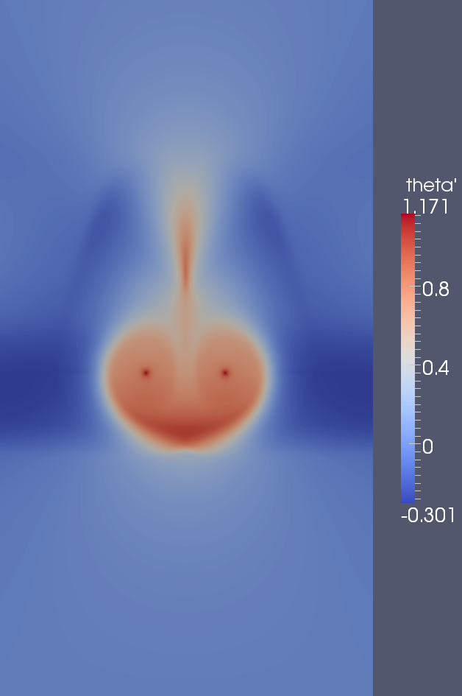 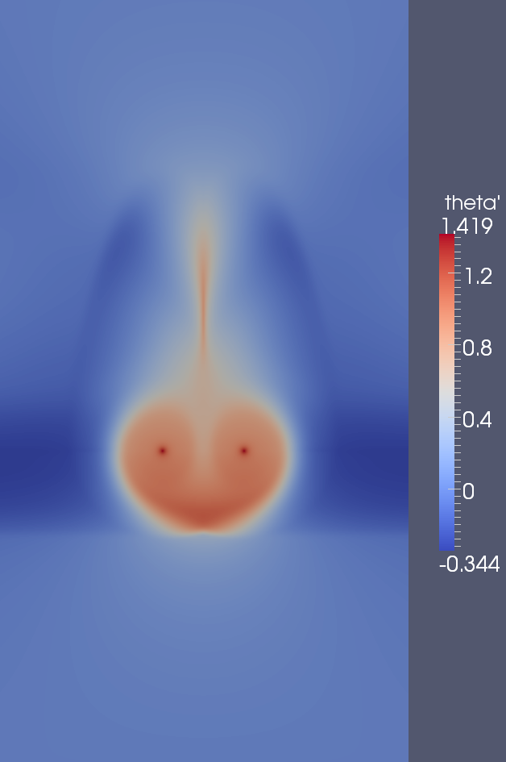

Figure 17: Potential temperature contours from the stably stratified simulation. From top left to bottom right the images are taken at 20, 40, 60, and 80 seconds.

Up to this point we have not explicitly considered the effects of stable stratification. We return now to the second numerical simulation that was performed for a stable atmosphere with a buoyancy period of 5.9 minutes. Stable stratification induces two important effects. The first of these is a progressively larger difference between the potential temperature inside the wake oval and the local ambient value outside. And as a consequence, the second important effect, which is the baroclinic generation of counter-sign vorticity due to the lateral gradient in potential temperature. The first of these two effects is illustrated in Figure , which shows the potential temperature perturbation evolution. To a certain extent, the fluid initially contained in the wake oval is trapped there as the vortices descend. This would be strictly true in an inviscid flow but in reality is only approximately satisfied due to turbulent entrainment and detrainment and due to turbulent conversion of kinetic to thermal energy (dissipation). In spite of this latter effect, Figure shows that the potential temperature perturbation grows in time and is mainly contained to the wake oval. As time progresses, a trailing potential temperature wake also develops above the vortex pair, and this is a direct result of turbulent detrainment (modeled by turbulent diffusivity, derived from the eddy viscosity with Pr=1). The darker red dots centered at the positions of the primary vortices are a potential temperature sources due to turbulent viscous dissipation.

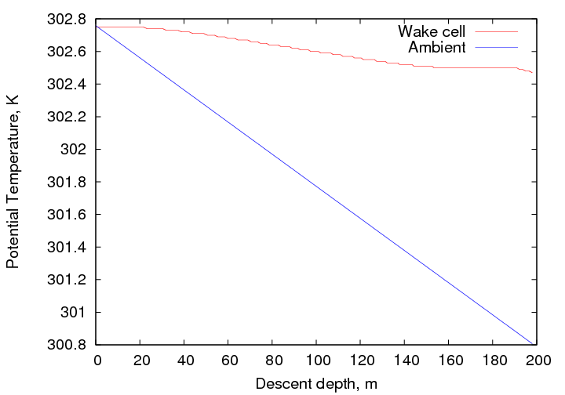

Figure 18: Average potential temperature within the wake oval compared to the local ambient as a function of the vortex pair descent depth.

Figure shows the average potential temperature within the wake oval compared with the local ambient value during the vortex pair descent. This figure indicates that the wake potential temperature is approximately fixed at its initial value. The slight loss in potential temperature is due to turbulent detrainment, which produces a net drain even when the input due to turbulent dissipation is added. Since the potential temperature within the wake varies so little on the descent we shall approximate it as being fixed at the initial value in what follows.

As stated above, the difference in potential temperature between the wake oval and the outside serves to generate vorticity. In order to see this, consider the vorticity equation under the Boussinesq approximation, which contains a baroclinic source term of the form

(29)

where is the potential temperature perturbation (relative to the ambient background) and is a reference value, which we shall take to be the ambient potential temperature at the initial wake altitude. This equation clearly shows that lateral variations in potential temperature act as vorticity sources. With reference to Figure we see that the regions near the edges of the wake oval should act as efficient vorticity source regions and that the vorticity produced will be counter sign with respect to the primary vortices. These conjectures are indeed born out in Figure which shows the vorticity field evolution from the stratified simulation. Notice the counter-sign vorticity that appears between the primary vortex and the deposition ring for the diffused primary vorticity. This effect is subtle at first but becomes more pronounced as time progresses.

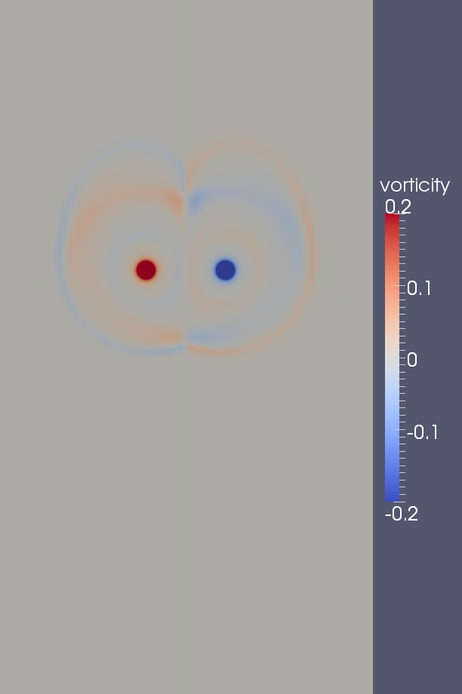 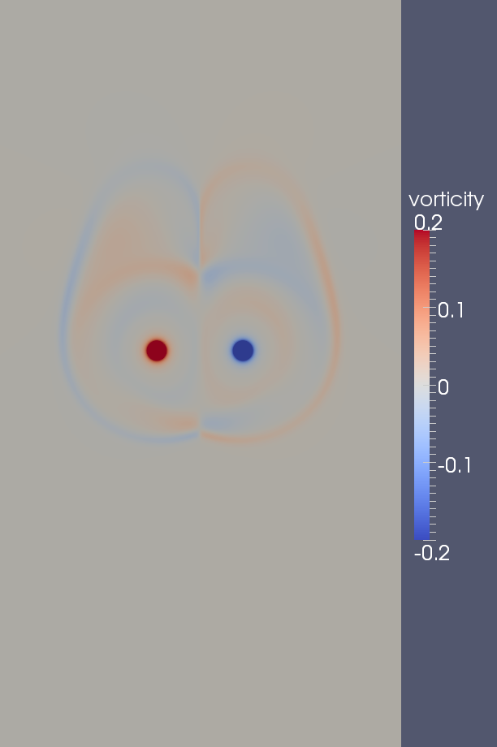

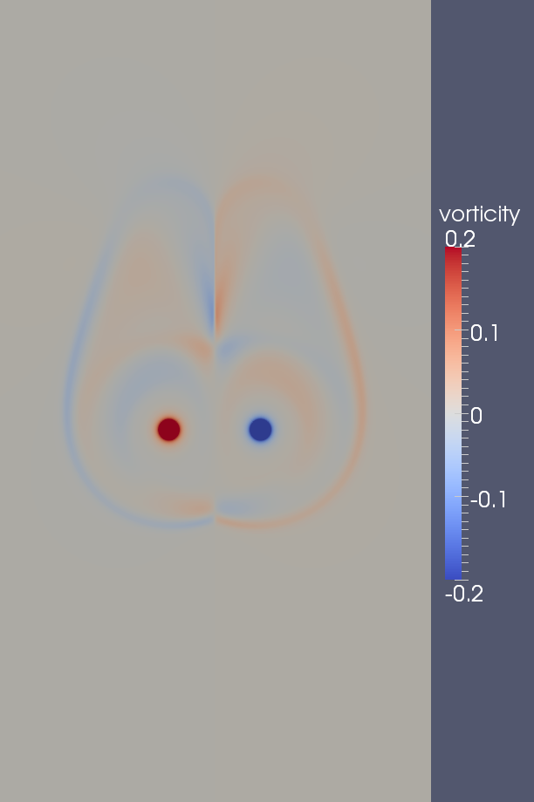 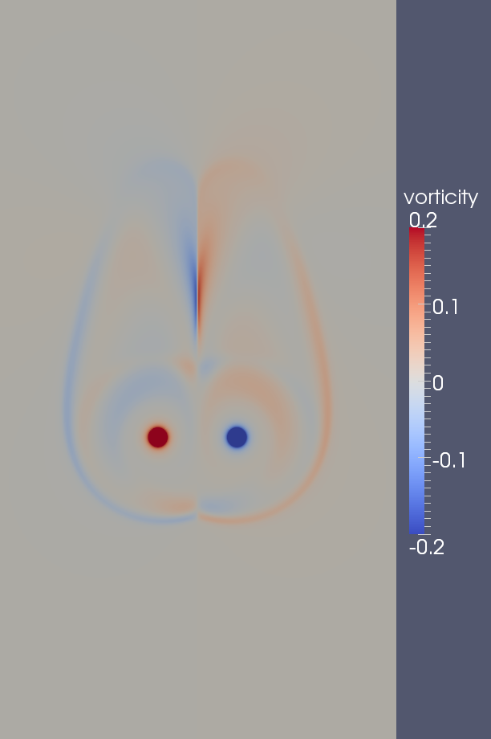

Figure 19: Vorticity contours from the stably stratified simulation. From top left to bottom right the images are taken at 20, 40, 60, and 80 seconds.

The effect of the baroclinically-generated vorticity is incorporated in the model by adjusting the strength of the halo vortices. To do this, we combine Eqs. () and () in order to arrive at the following equation for the rate at which the circulation in the halo is adjusted due to baroclinic generation

(30)

where is the circulation due to baroclinic generation. The integration is carried out over the annular region depicted in Figure and the integral is performed in a Cartesian coordinate system as indicated by the sample element. The outer ring of the annulus is positioned at *r*=*b*/2, which is half the separation distance between the primary vortices. Figure indicates that this is the approximate outer extent of the baroclinic vorticity generation zone.

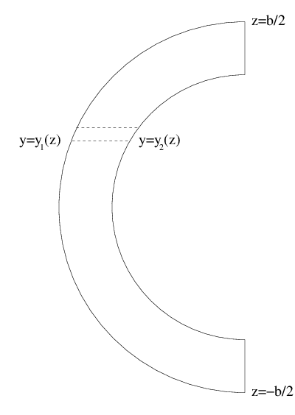

Figure 20: Area of integration for computing the rate at which circulation changes as a result of baroclinic generation.

Since it follows that , and thus the inner integral in Eq. () readily evaluates to

(31)

Now, is the potential temperature within the wake oval, which we shall approximate as being constant and equal to . Additionally, is the ambient value, which can be written as , where is the altitude of the primary vortex and α is the local potential temperature lapse rate.

Returning to Eq. () with the above simplifications, we obtain the final result

(32)

This very simple equation is integrated in time in order to determine the adjustment to the halo circulation due to baroclinic generation. As in the case with the halo circulation, we must account for losses due to destruction along the vortex pair symmetry line where baroclinic vorticity from either side of the wake oval diffuses together. We account for the loss via the same attenuation function used in Eq. () and defined in Eq. (). Accounting for losses along the symmetry line, the above equation integrates to

where is the net change in circulation due to baroclinic action, accounting for losses along the symmetry line.

The only remaining detail is to partition the baroclinic circulation adjustment among the three halo vortices. Since the baroclinic generation source term is maximized along the *y* axis, one would expect that the partition fraction for halo vortex 2 should be the largest. This was indeed found to be the case when a tuning exercise was performed using the Frankfurt 2004 aircraft landing data. Unlike the diffused vorticity halo vortex circulation partitions, the baroclinic fractions do not appear to require a time dependence. Thus the following static adjustments to the halo vortex circulations are currently in use

Aside from the baroclinic generation effect, stable stratification also affects the primary vortex decay rate. This effect was parameterized from the aircraft landing data via the following simple correction involving the local non-dimensional buoyancy frequency, .

(33)

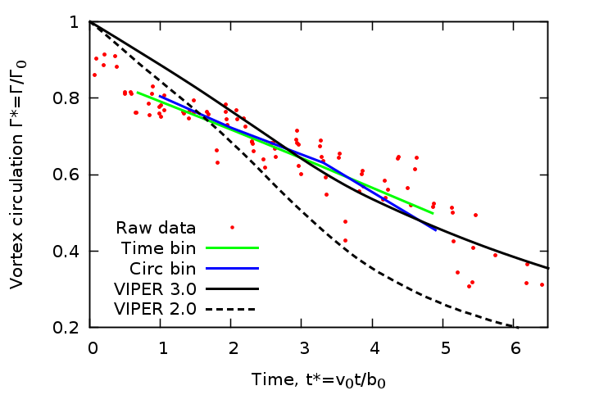

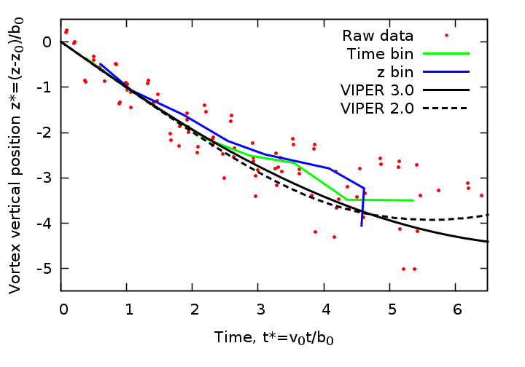

Figure 21: Comparison of the model prediction against the moderate stable stratification landing data.

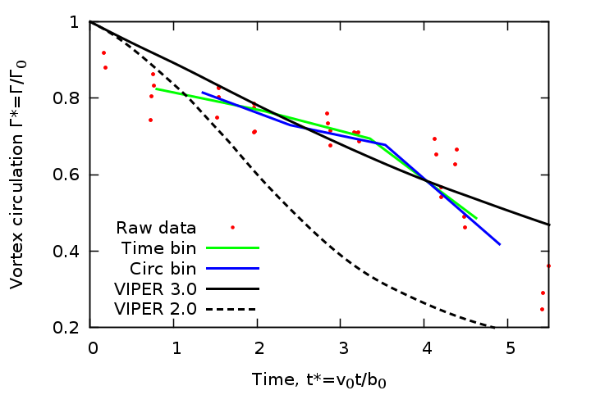

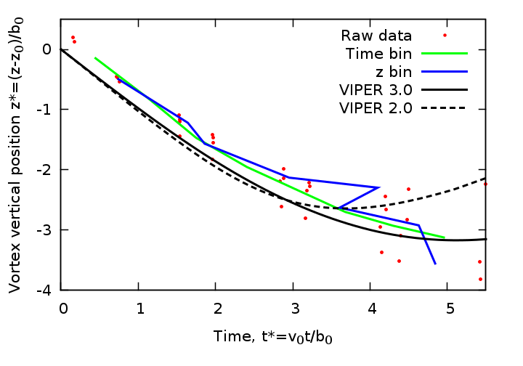

Figure 22: Comparison of the model prediction against the high stable stratification landing data.

The success of the stable stratification treatment is demonstrated in Figures and for moderate and high stable stratification cases respectively.

### 5.8 Incorporating the Effects of Crosswind Shear Gradients

Variable crosswinds can have a profound impact of the evolution of the aircraft vortex wake system. At the simplest level, crosswinds advect the vortices laterally and this effect can easily displace them by a few kilometers before they dissipate. The advection effect is easy to model as it simply translates the vortex system at the local crosswind speed. In addition to the advection effect, variations in the crosswind with altitude induce additional effects that are much more difficult to model. A linear change in the crosswind with altitude produces a wind shear that skews the halo vorticity trailing above the current position of the wake system. This skewing produces a small asymmetry to the induction caused by the halo and results in a small tilting of the primary vortices. A numerical simulation of a linear crosswind profile was performed and analyzed, but the net effects on the primary vortex system were found to be sufficiently small that they did not warrant specific changes to the model. This is especially true in light of the much stronger effects produced by non-linear crosswind profiles which will be discussed next.

Non-linear variations in the crosswind with altitude can produce significant changes to the evolution of the vortex system. As discussed in more detail below, non-linear variations in the crosswind imply a variable background vorticity field that interacts with the vortex wake system. To see this, note that the component of vorticity of interest is , where the latter near equality is due to the fact that the (time averaged) vertical component of wind is typically much smaller than the crosswind component. Since the vorticity is nearly equal to the vertical derivative of the crosswind, we see that a linear crosswind profile results in a constant background vorticity field. A uniform background vorticity field will have no net effect on the wake vortex system other than the skewing of the trailing vorticity as discussed above. The definition of vorticity also tells us that crosswind profiles having quadratic and higher order variations will result in variable background vorticity fields. A variable background vorticity field can interact with the vortex wake system since the primary vortices induce strong vertical motions which redistribute the background. This interaction produces a gain in circulation on one side of the vortex system and a reduction in circulation on the other. This imbalance introduces an asymmetry that results in a pronounced tilting of the vortex system. A pronounced tilt in conjunction with the ongoing asymmetric interaction with the background vorticity field can produce additional, surprising effects such as pronounced separation of the primary vortices and even a "rebound" where one or both of the vortices reverses its vertical motion and rises with time. While these strongly non-linear effects are notoriously difficult to model, we have found a fairly straightforward way to incorporate them by introducing the correct type of asymmetry to the halo vortex system. As before, we use numerical simulation data as a basis for constructing the quadratically variable crosswind component of the model.

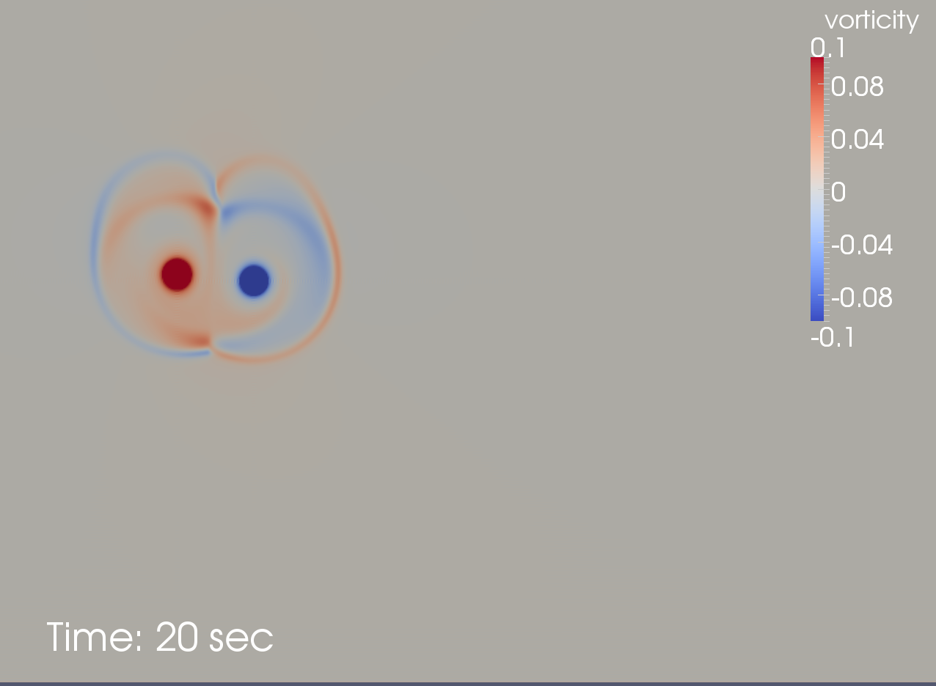 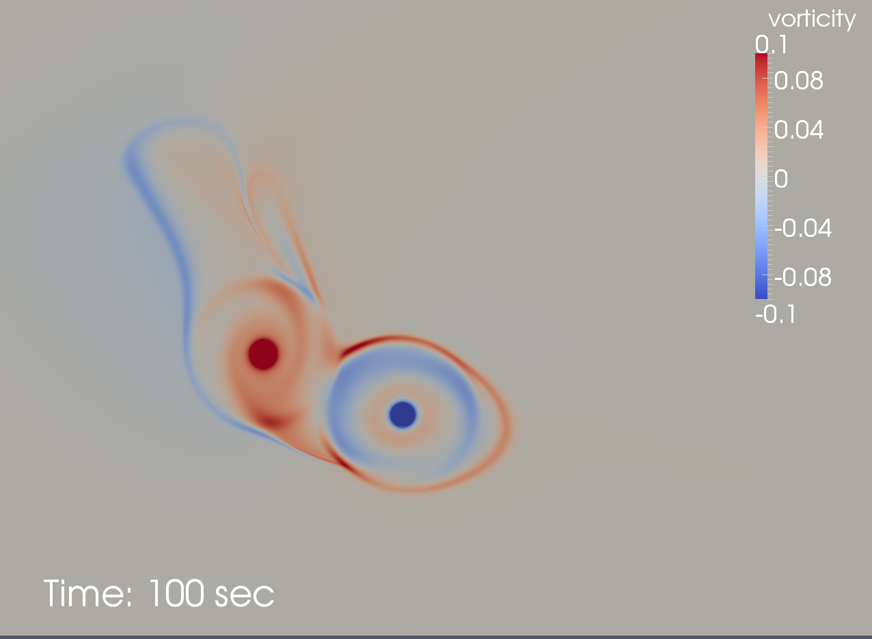

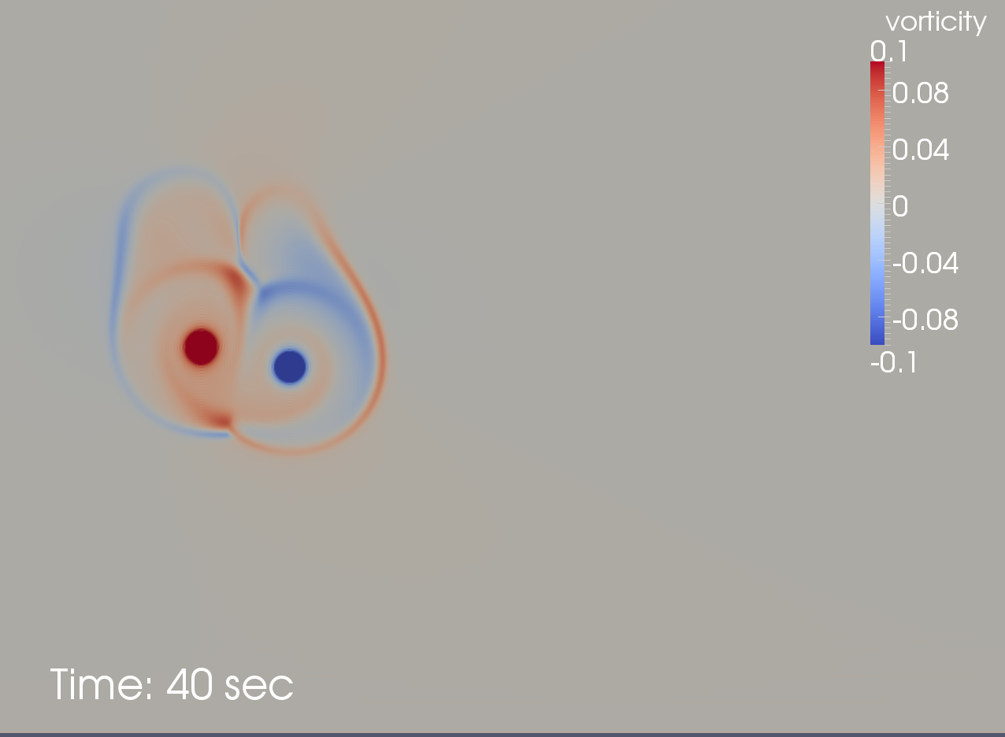 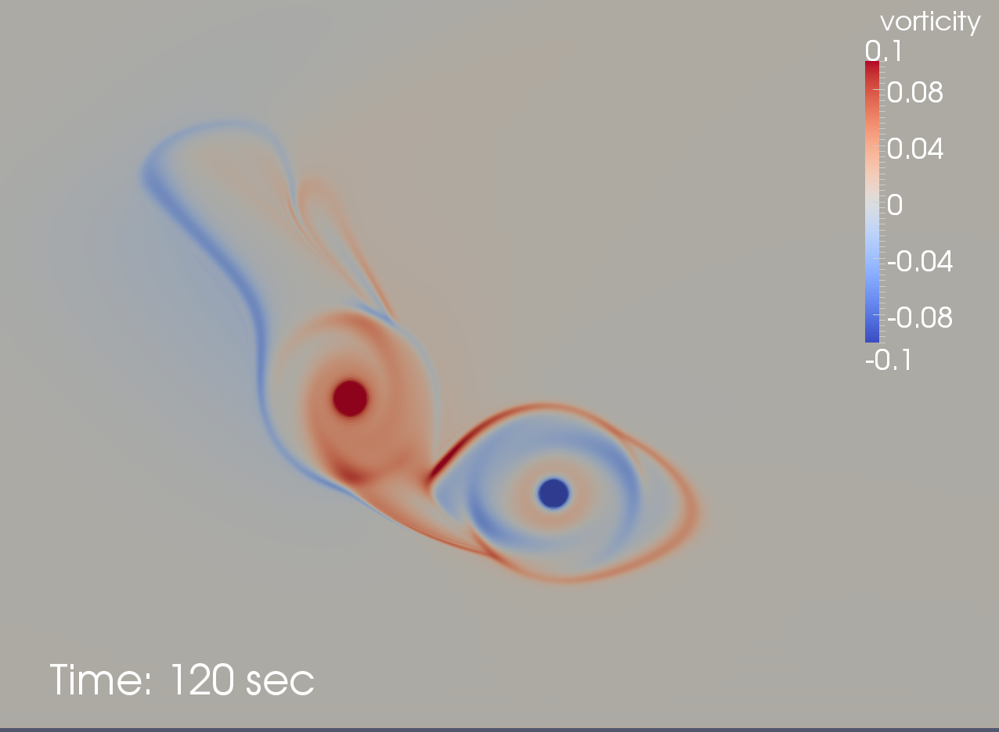

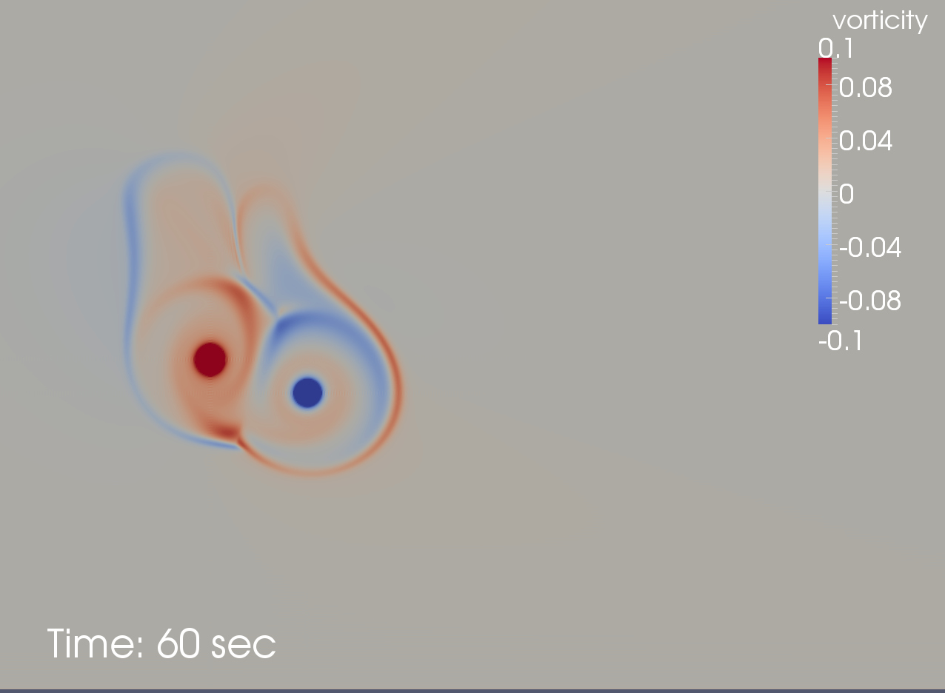 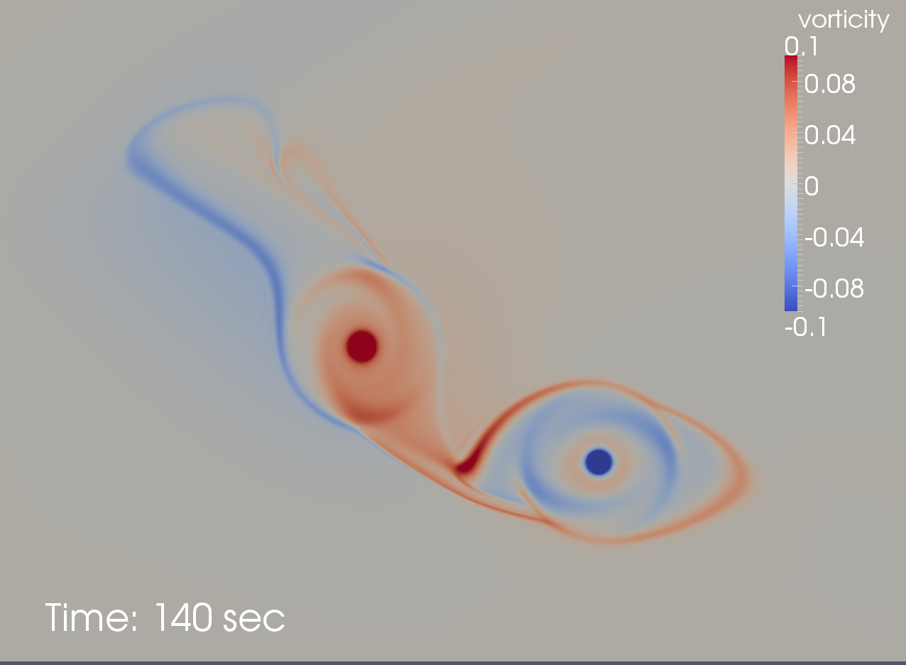

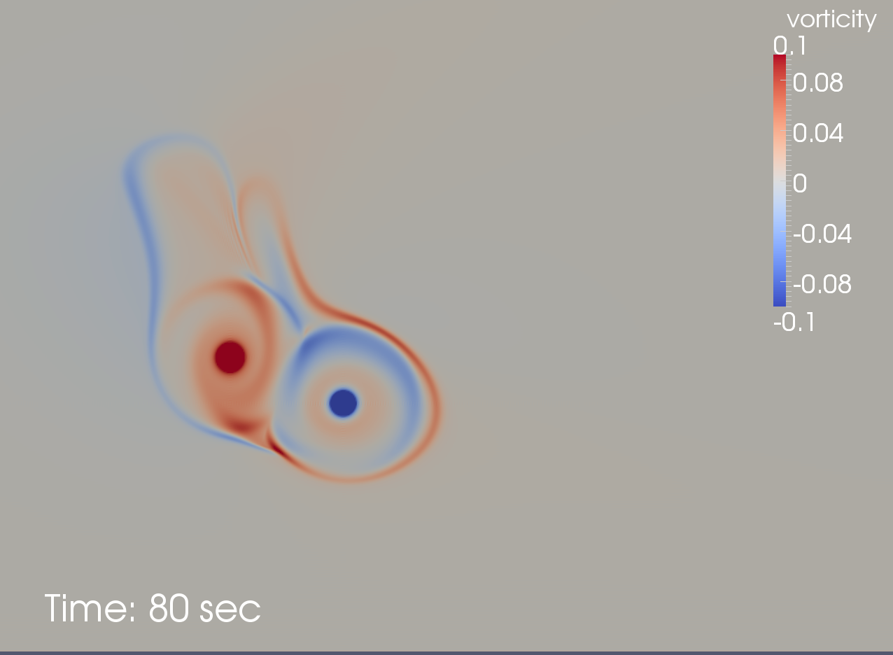 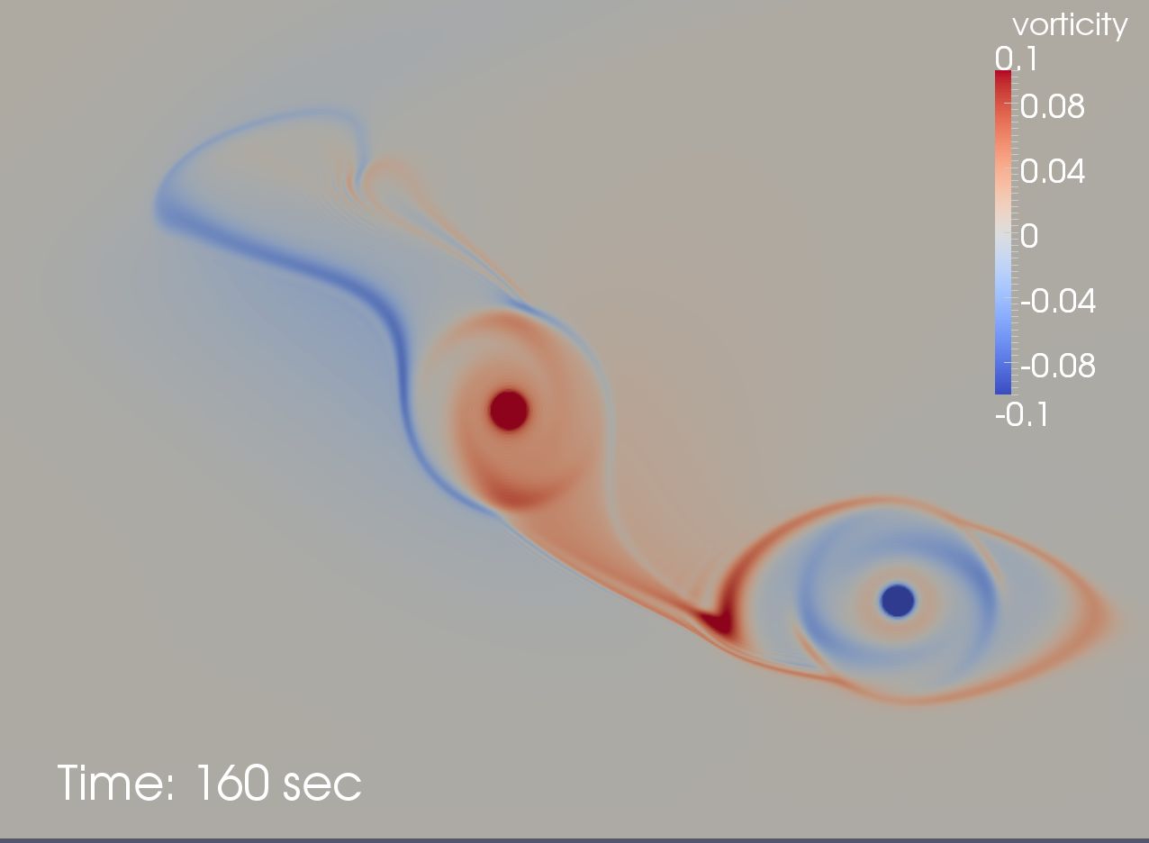

Figure 23: Perturbation vorticity contours from the crosswind shear gradient simulation. From top left to bottom right the images are taken at 20, 40, 60, 80, 100, 120, 140, and 160 seconds.

### 5.9 Numerical Simulation Including a Crosswind Shear Gradient

The vortex pair simulation discussed in Section 4 was repeated with the following crosswind profile

(34)

This profile results in a constant second derivative, which give the following value for the non-dimensional shear gradient

(35)

A time sequence of vorticity fields from the crosswind shear gradient simulation is shown in Figure . The vorticity due to the imposed crosswind distribution has been subtracted and thus the images depict the disturbance relative to the background. The advection and tilting of the primary vortices is readily apparent. Closer scrutiny shows that the primary vorticity on the port side is enhanced while the primary vorticity on the starboard side is reduced.

The numerical simulation was used to measure the time histories of the primary vortex circulations. Due to interactions with the background vorticity field, the primary vortex circulations develop an asymmetry, which can modeled as

(36)

(37)

where *H*() is the Heavyside function, is the nominal circulation decay rate given in Eq. () and where and are a pair of constants whose values switch depending on the sign of :

(38)

The Heavyside function is used to deactivate the circulation asymmetry during the initial vortex roll-up period. The Frankfurt aircraft landing data do not exhibit circulation asymmetry for for times less than about , even though crosswind shear gradients may be present during this time. Better agreement with the landing data is achieved by simply deferring the circulation asymmetry effect for about one half a non-dimensional time unit.

In contrast to the Frankfurt aircraft landing data, the numerical simulation results show an immediate circulation asymmetry response to crosswind shear gradients. This may be due to the fact that the simulation is initiated with two concentrated vortices, and thus does not pass through a vortex roll-up stage. As shown in Table , we can account for this difference by taking when attempting to model the numerical simulation.

As with the case with the vortex roll-up time, optimal values of the constants and differ somewhat between the numerical simulation and the Frankfurt landing data. While the numerical simulation data is fit best with distinct values for the constants and , the large degree of variability in the Frankfurt landing data make it difficult to resolve any differences between the two constants. For this reason, a common value for and is used for the landing data. The single value fits the data reasonably well and has the side benefit of simplifying the model slightly. Table summarizes the values used for both the simulation and the landing data.

|  |  |  |  |
| --- | --- | --- | --- |
| Case |  |  |  |
| Simulation | 0.35 | 0.70 | 0.0 |
| Landing Data | 0.35 | 0.35 | 0.5 |

Table 3: Crosswind shear gradient induced circulation asymmetry parameters.

Asymmetry in the primary vortex circulation results in a net circulation that must be distributed among the halo vortices if the system is to conserve total circulation. This distribution naturally takes the form of a partition scheme analogous to that developed for the diffused primary circulation. The quantity to be partitioned is

(39)

Since and are of opposite signs, will vanish unless there is an difference in magnitude in the circulations of the two primary vortices. When there is a difference, the sign of is dependent on the sign of , and thus automatically adjusts for the sense of the shear gradient. In principle can be partitioned in an arbitrary manner among the six halo vortices. In practice, we have obtained satisfactory results with a simpler scheme where half of is allocated to the three halo vortices on the port side, and the other half is allocated to the halo vortices on the starboard side. This approach has the advantage that only two partition factors need to be determined for each half of the halo vortex system. Since the crosswind shear gradient induced circulation is additive to the primary diffused circulation and baroclinically-generated circulation, the partition scheme given by Eq. () (for the port side) is modified to give

(40)

The numerical simulation data was used to determine the partition factors , , , and . These factors exhibit variations in time that can be represented adequately with linear fits. Additional accuracy is achieved with with second order polynomials, and we use these here for demonstration purposes. The success of the shear gradient component of the model is shown in Figure , where the circulation time histories and the vortex trajectories given by the model are compared with the numerical simulation data. The model does a excellent job at predicting both the vortex circulation and its position.

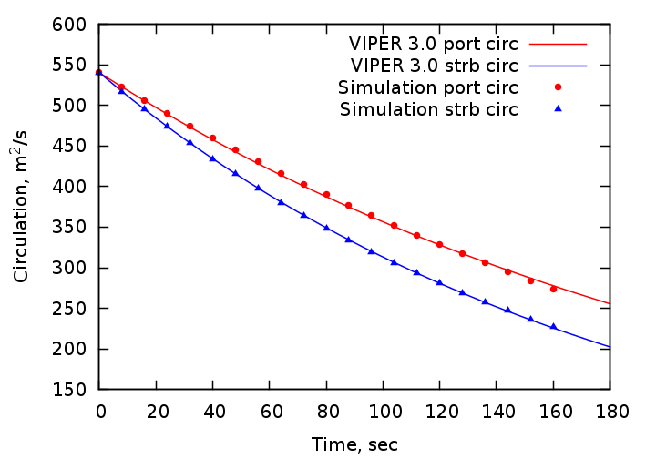

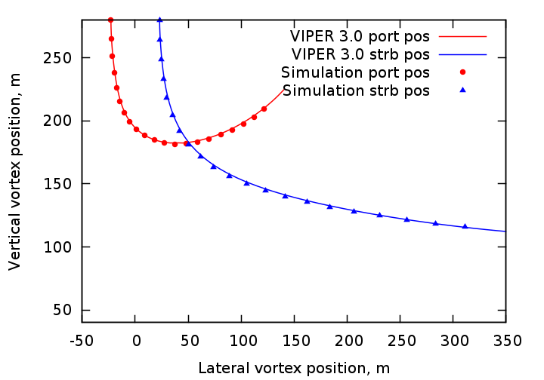

Figure 24: Model prediction compared with the numerical simulation data for the crosswind shear gradient case. The top figure shows the circulation decay and the bottom figure shows the vortex trajectory.

The curve fits for the shear gradient partition factors determined for the numerical simulation proved to be somewhat inaccurate for the Frankfurt landing data. While attempts were made to find appropriate linear or quadratic fits for the landing data, the large variability within these data made it difficult to find fits that would apply across a large number of separate landing events. In the end it was determined that constant partition factors worked just as well as more elaborate fits. The values of the constant factors flip between the port and starboard sides with respect to the sign of the shear gradient according to

(41)

Due to an acute sensitivity to the details of the crosswind profile, it is not possible to combine multiple landing cases for comparison with the model as has been done for the baseline, turbulence, and stable stratification cases discussed previously. Instead we compare a single case that is representative of moderate to strong crosswind shear gradients. These results are shown in Figure . For comparison, the prediction of the VIPER 2.0 model is included in these figures.

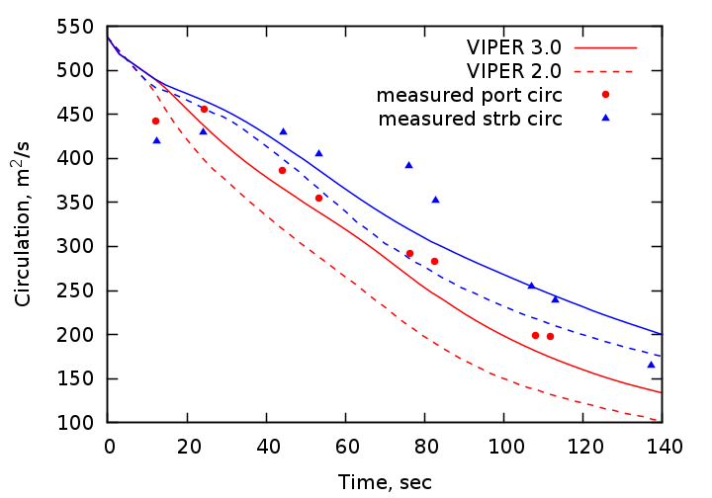

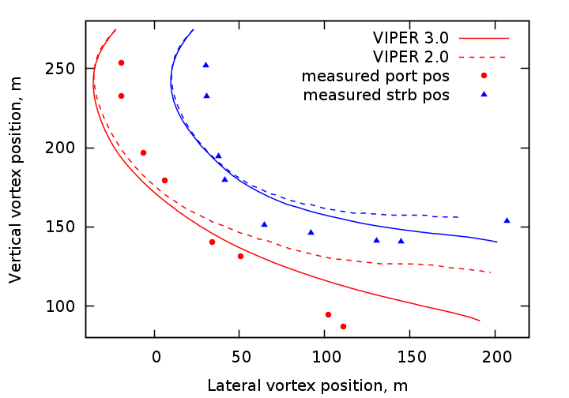

Figure 25: Model prediction compared with case OGE-B744-155 of the Frankfurt 2004 landing data. The top figure shows the circulation decay and the bottom figure shows the vortex trajectory.

While both VIPER 3.0 and VIPER 2.0 predict the circulation asymmetry reasonably well, the VIPER 3.0 model is slightly more accurate. The same thing can be said regarding the vortex trajectory, where the VIPER 3.0 model shows a slight advantage. These results are typical of other cases with significant crosswind shear gradients in the Frankfurt 2004 landing data where VIPER 3.0 is almost always more accurate than VIPER 2.0.

## 6 Summary

A new fast vortex wake model that makes use of an analytic vortex diffusion model in conjunction with simple vortex induction scheme has been developed. This model represents a departure from traditional models that rely on a control volume analysis in order to predict the primary vortex decay and trajectory. Compared with these traditional models, our new model is much simpler to understand, program, and modify, and yields predictions that are typically more accurate than the control-volume based VIPER 2.0 model.

At the core of VIPER 3.0 is an analytic model for the primary vortex decay which is built on experimental observations. This model predicts an initial linear rate of decay followed by an exponential decay for asymptotically late times. One important by-product of the analytic vortex decay model is the radial distribution of eddy viscosity required to produce the experimentally-observed profile shape and circulation decay rate. This feature enables detailed numerical simulations of vortex pairs subject to environmental factors such as turbulence, buoyancy, and wind shear gradients. Simulations of this type were undertaken and the resulting data were used to develop the vortex induction component of the model. The numerical simulation results show that the vorticity diffused from the primary vortices is largely deposited in rings or "halos" at a radius slightly greater than one half the separation between the two vortices. The halo vorticity induces a velocity field that plays an important role in the trajectory of the primary vortices. The net induction due to the halo is modeled as a system of six discrete vortices surrounding the primary vortex pair. The numerical simulation data was used to determine optimal positions and distributions of the halo vorticity among the six vortices, while ensuring a global conservation of circulation. Making use of both numerical simulation and aircraft landing data, appropriate adjustments to the model were made in order to account for the effects of ambient turbulence, buoyancy, and crosswind shear gradients.

While the VIPER 3.0 model contains a number of parameters, most of these appear to be universal and thus may be taken to be constants. In fact, only one parameter required small adjustments in order to match both the numerical simulation and Frankfurt 2004 aircraft landing data when the effects of turbulence and buoyancy are to be accounted for. The crosswind shear gradient component of the model is not as robust, however, and a total of 7 parameters were adjusted in order to simultaneously match the numerical simulation and aircraft landing data.

The VIPER 3.0 model is very simple and efficient to program. It requires less than 500 lines of code, which may be compared to almost 2500 for VIPER 2.0. The simplicity of the code is a significant advantage since it is very easy to understand and to modify. The model also automatically accounts for the presence of the ground plane and thus is also applicable to altitudes in the near ground effect regime. At lower altitudes, VIPER 3.0 turns the solution over to the in ground effect (IGE) component of the viper model. It is worth noting that the VIPER_IGE model itself uses a vortex induction scheme instead of a control volume analysis. Thus the VIPER 3.0 model is consistent in its modeling approach of the OGE and IGE regimes.

References

[1] Burnham, D. C., J. N. Hallock, I. H. Tombach, M. R. Brashears, and M. R. Barber, “Ground-Based Measurements of the Wake Vortex Characteristics of a B-747 Aircraft in Various Configurations,” Department of Transportation, Transportation Systems Center, FAA-RD-78-146, Cambridge, MA, 1978.

[2] Burnham, D. C., and J. N. Hallock, “Chicago Monostatis Acoustic Vortex Sensing System, Volume IV: Wake Vortex Decay,” FAA-RD-79-103, Transportation Systems Center, Cambridge, MA, 1982.

[3] Burnham, D. C., and J. N. Hallock, “Decay Characteristics of Wake Vortices from Jet Transport Aircraft,” *J. Aircraft*, **50**, 82-87, 2013.

[4] Delisi, D. P, G. C. Greene, R. E. Robins, D. C. Vicroy, and F. Y. Wang, “Aircraft Wake Vortex Core Size Measurements,” AIAA Paper 2003-3811, 21st Applied Aerodynamics Conference, Orlando, FL, June 23-26, 2003.