VIPER 3.0 Fast-Time Wake Decay and Transport Model: User’s Guide

NorthWest Research Associates,

4118 148th Ave NE

Redmond, WA 98052

Engility Corporation

-------------------------------------------------------------------------------------------------------------------------------

# Contents

Contents ii

Table of Acronyms and Abbreviations ii

Abstract 1

1. Introduction 1

2. Software Package……………………………………………………………………………….3

3. Installing the VIPER GUI for Microsoft Windows 3

4. VIPER Video Tutorials 5

5. Running VIPER’s Graphical User Interface 6

6. VIPER input files 11

7. VIPER output files 13

8. VIPER file listing 14

8.1. VIPER Source-Code Layout 14

9. VIPER model description 19

Bibliography 19

# Table of Acronyms and Abbreviations

AGL Above Ground Level

APA AVOSS Prediction Algorithm

AVOSS Aircraft VOrtex Spacing System

EDR Eddy Dissipation Rate

FAA Federal Aviation Administration

GUI Graphical User Interface

IGE In Ground Effect

NGE Near Ground Effect

OGE Out of Ground Effect

SI System Internationale (or International System) of units

VIPER Vortex Algorithm including Parameterized Entrainment Results

# Abstract

VIPER 3.0 is a physics-based fast-time wake model for real-time predictions of aircraft wake vortex evolution. Model inputs include ambient temperature, wind, and eddy-turbulence profiles, as well as parameters characterizing specific aircraft types. Model predictions include wake vortex trajectories and circulation magnitudes as a function of time. Results are tabulated and presented graphically. This document describes how to install and run the model, its required input data, and the output data it generates and displays.

# 1. Introduction

Fast-time wake models are empirical or semi-empirical algorithms used for real-time predictions of wake evolution and decay based on aircraft parameters and ambient weather conditions. The aircraft parameters include the initial vortex circulation strength (0) and vortex-pair separation distance (*b*0). The atmospheric initial conditions include vertical profiles of temperature or potential temperature (), eddy dissipation rate (), crosswind, and headwind. The atmospheric parameters that affect wake decay are atmospheric stratification, turbulence, and vertical wind shear gradient.

VIPER 3.0 is the latest evolution in a line of fast-time wake vortex model. The VIPER 3.0 model includes a realistic treatment of stratification effects by modeling the baroclinically-generated vorticity resulting from the potential temperature gradients set up by the vortex system. VIPER 3.0’s evolution equations are based on the observed vortex wake physics from aircraft landing data. At the core of VIPER 3.0 is an analytic model that predicts the circulation decay. Parameters in this model naturally account for the turbulence- and stable stratification-induced changes to the baseline decay rate. This model also predicts the eddy viscosity distribution necessary to achieve the observed circulation decay rate as well as the observed radial distribution of circulation. This eddy viscosity distribution has been used to conduct high-resolution numerical simulations of vortex pairs, both in quiescent conditions and subject to stable stratification and crosswind shear gradients. The numerical simulation data were used to develop the vortex induction component of the VIPER 3.0 model, which predicts the vortex trajectories. This component of the model is based on a collection of six discrete “halo” vortices surrounding the vortex pair and these represent the net effect of the vorticity diffused from the primaries. The positions of the halo vortices (relative to the primaries) remain fixed, but their circulations vary in time according to observations from the numerical simulations. The circulations of the halo vortices are adjusted for the baroclinically-generated vorticity under stable stratification conditions as well as for the interaction with a variable-vorticity background present under the conditions of crosswind shear gradients. The underlying model as well as the adjustments for stable stratification and wind shear gradients satisfies a global conservation of circulation.

Application of VIPER 3.0 to the Frankfurt 2004 aircraft landing data showed that it can accurately model aircraft wakes under a wide range of environmental conditions including stable stratification, crosswind shear gradients, and ambient turbulence. The model is very easy to understand, program, and modify and typically results in more accurate predictions than its predecessor, VIPER 2.0. VIPER 3.0 uses an image vortex system to account for the presence of the ground and thus is applicable both in the Out of Ground Effect (OGE) as well as Near Ground Effect (NGE) regimes. For the In Ground Effect (IGE) regime, VIPER 3.0 hands off the solution to the IGE component of the VIPER model. This component itself makes use of a vortex induction model and thus the combination VIPER 3.0 model is consistent in its modeling approach across the OGE and IGE regimes.

By way of review, the VIPER_IGE model includes the secondary vorticity generated at the ground when the primary vortex pair is close to the surface. The secondary vorticity is observed to periodically separate from the surface to form discrete vortices. The formation of these secondary vortices, as well as induction that they create is the key task undertaken by the VIPER_IGE model. Typically the secondary vortex induction results in a “rebound” where the primary vortices reverse course and move upwards, away from the ground. The magnitude of the resulting rebound depends on both the ambient crosswind and headwind, with the downstream vortex generally achieving a higher rebound. Enhanced circulation decay near the ground occurs because of ground friction and mixing/diffusion with the secondary vorticity generated there.

# 2. Software Package

The VIPER 3.0 model is packaged in a convenient Graphical User Interface (GUI) that automatically runs the computer code and displays the vortex wake circulation decay, vortex trajectories, and environmental conditions. The GUI relies on input data files where the aircraft parameters as well as any measurement data are specified. These are human-readable ASCII files that are easy to understand and create. While input files can be created by any convenient means, the GUI also contains a facility for generating them. Lastly, the GUI contains a preference menu that provides a considerable number of options for customizing the display.

The GUI was originally developed for the VIPER 2.0 model. The only change to the GUI made for VIPER 3.0 is an option to run this model in the preference pane. Using this feature, the user may select to run the VIPER 2.0 model, the VIPER 3.0 model, or both simultaneously for comparison.

Since both versions of the VIPER model share a common GUI, the install procedure is identical to that which was developed for VIPER 2.0. **If you already have the VIPER GUI installed, then the VIPER 3.0 component will be installed automatically the next time you start the GUI**. Alternatively, you can run the script ViperUpdate in order to add the VIPER 3.0 component outside of the GUI. If you do not have the VIPER GUI installed, you can follow the instructions in the next section to install it.

# 3. Installing the VIPER GUI for Windows

The following procedure outlines how to install the VIPER GUI on a Microsoft Windows platform. **Only perform these steps if you do not have an earlier version of the VIPER GUI installed.** If you do have an earlier version installed, then the VIPER 3.0 component will be added automatically the next time you start the GUI.

1. You will need administrator privilege in order to install the required programs to your computer. Either log in as administrator, or as a privileged user.
2. If you have a 32-bit system, download the ViperInstaller32.EXE file. It is located on the VIPER Distribution CD in the following location: ViperInstall/ViperInstaller32.EXE. If you have a 64-bit system, download the ViperInstaller64.EXE file. This file is located on the VIPER Distribution CD in the following location: ViperInstall/ViperInstaller64.EXE.
3. Double click on the downloaded installer file. Agree to install the programs on your computer.
4. Your system may ask you to verify that you want to install one or more of the components. Agree.
5. If the installer seems to be stalled, check to make sure that a dialog is not present somewhere asking you to verify the installation of one of the packages. The dialog may be stowed, as indicated by a flashing icon on the lower task bar.
6. The VIPER programs and GUI will be installed in your home directory in a folder named ViperMS. If you are not sure what your home directory is, type echo %userprofile% in a command prompt window.

# 4. VIPER Video Tutorials

The following video tutorials are included with your distribution and are helpful for learning how to run the VIPER GUI:

Lesson 1 – Overview of installed components

Lesson 2 – Introduction to the Graphical User Interface (GUI)

Lesson 3 – Managing the run list

Lesson 4 – Using the run controls

Lesson 5 – Constructing a new case

Lesson 6 – Adding aircraft and airports to the database

These tutorials can be found on the VIPER 3.0 Distribution CD at the following link:

Tutorials/Lessons.html

It is highly recommended that you watch each of these videos in their entirety to become familiar and proficient with the GUI.

In addition, we also outline below basic operations required to get up and running with the VIPER GUI.

# 5. Running the VIPER Graphical User Interface

Once the program is installed on your system (see Section 3, Installing VIPER for Windows), perform the following steps to start the GUI.

1. Navigate to the installation folder ViperMS.
2. Double click on the file ViperGui.pl to initiate the Graphical User Interface (GUI).
3. In the left panel of the GUI (see Figure 1) you will find a list of the most recently run aircraft-landing data files. Highlight one of the landings with your mouse and click “Run next”, “Run selected”, or “Run all” to produce VIPER output.
   1. If no items appear in the left panel of the GUI, then no landings are preloaded. You can load a landing data file by clicking “Add to run list”. A dialog box will appear displaying a list of available .vpi data files and .lst list files (which contain lists of data files). The data files only, list files only, or both data and list files can be made visible by adjusting the drop-down menu labeled “Files of type:”.
   2. Select the files you would like to load and press “Open” or the “Return” key.
   3. You can navigate to alternate data folders on your computer by pressing the “Directory:” menu option.

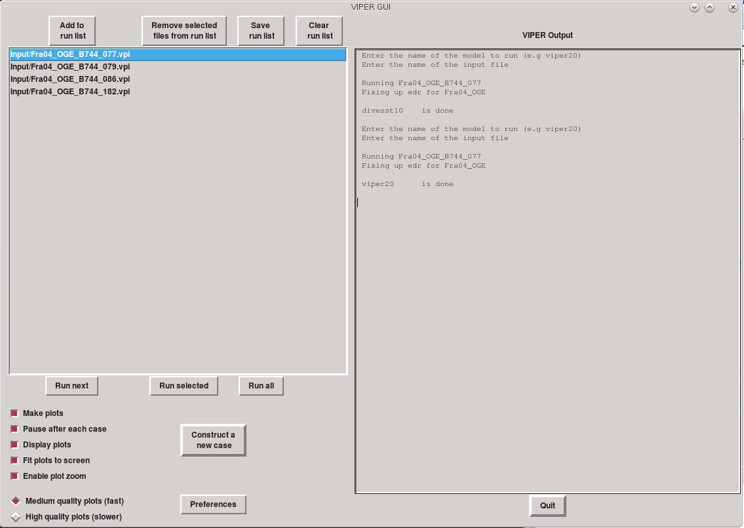

Figure VIPER Graphical User Interface (GUI) main window.

1. To create graphical output, the “Make plots” checkbox must be selected (the checkbox will turn red when selected). Otherwise only text-based output files will be generated, and no output graphics will be generated.
   1. If the checkbox “Display plots” is selected, then the GUI will display graphical output on your computer screen for the run; see Figure 2.
   2. Various other options in nearby checkboxes (e.g., “Pause after each case”, “Fit plots to screen”, “Enable plot zoom”, “Medium quality plots (fast)”, and “High quality plots (slower)” control details of the interactive graphical output).

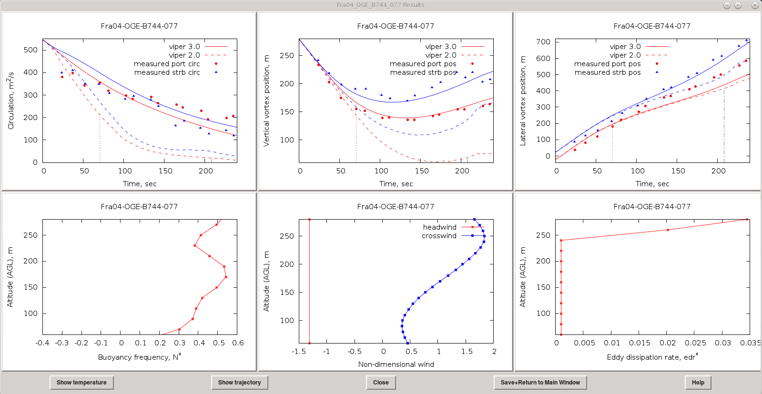

Figure VIPER GUI output window.

1. Buttons along the top of the GUI’s left panel allow you to “Remove selected files from [the] run list”, “Save [the displayed] run list”, and “Clear [all items from the] run list”.
2. The right panel displays text output from the VIPER Fortran programs.
3. The output graphics are presented as a 3-by-2 array of plots (see Figure 2) with model output (solid lines) in the top three panels along with aircraft-wake measurement data (plot symbols). In these plots, red is used for the port vortex measurements and predictions, and blue is used for the starboard vortex measurements and predictions. The port and starboard circulations (left-top panel), altitudes (center-top panel) and lateral positions (right-top panel) are presented, along with environmental profiles for stratification (left-bottom panel), crosswind and headwind (center-bottom panel), and atmospheric turbulence (right-bottom panel).
4. Several controls are available as buttons along the bottom of the output display window. Clicking on the “Show temperature” button will produce a plot of the temperature profile (the potential temperature profile is show in the six-panel display). Similarly clicking the “Show trajectory” buttons will produce a plot of the vortex trajectory (vertical vs. lateral position). The “Close” button will destroy the plot window, whereas the “Save+Return to the Main Window” will retain the plot window and bring the GUI window back to the front. Finally the “Help” button will bring up a window with a similar discussion of buttons just presented here.
5. If multiple cases are selected to be run on the main GUI panel (via the “Run selected” or “Run all” buttons), then the user is presented with a slightly different collection of buttons at the bottom of the plot window. Specifically the “Close” button is replaced the “Close+Advance” and the “Save+Return to the Main Window” is replaced with “Save+Advance” These two buttons do the obvious thing of either closing or saving the current plot window while advancing to the next case in the selected list. Finally, a new button “Abort Sequence” allows the user to terminate processing of the selected cases and returns the main GUI panel to the top. The “Help” button summarizes all of these functions.
6. To create a new input data file for an aircraft landing, click the “Construct a new case” button on the left side of the GUI. A panel will appear to aid you in this operation (see Figure 3). The name of the “File to store the [new] input data” is specified near the top of the panel on the left. Aircraft type and related parameters (e.g., wingspan, weight, wingtip vortex spacing, etc.) can be specified using the left-most panel. The airport and runway and related parameters can be selected using the center panel. Finally, environmental properties for surface wind speed and direction, pressure, stability, and turbulence can be specified with the right-most part of the GUI.
7. Clicking on the “Preferences” button on the main GUI panel brings up the dialog shown in Figure 4. The upper left quadrant of the preferences pane is devoted to setting the plot limits. The user can either specify the plot limits explicitly or choose the “Autoscale” option. When autoscaling is used, it is also possible to specify a unit of measure by which to round the limits implied by the model output and/or the measured data. For the time axis, the user may to elect to autoscale based either on the model output or on the measured data. The upper right portion of the preferences panel allows the user to control the size and position of the main GUI window, the plot display window and model output sub-portion of the main GUI window. While the default values along with “Autodetect” for the plot display window are usually adequate, the user may want to reduce the size of the display window, or add offsets to avoid covering up an important screen feature such as the task bar. The bottom left sub-area is used to select the model(s) to run as well as the labels to be used in the output plots. Currently, the user may choose viper30 (for VIPER version 3.0) and/or viper20 (for VIPER version 2.0). If only a single model is to be run, its name should be entered in the “Model 1” box and the “Model 2” box should be empty. At the bottom right corner of the preferences window are controls for customizing a few plot details. The user may select a a number of points by which to enlarge the font used for labels on the plots. The checkbox “Show Instability times” will depict the time for vortex short-wave instability and for vortex linking as faint dashed vertical lines on the plots. The user can also select between viewing the lateral vortex position as y vs. time or as z vs y. Finally, at the bottom of the preference window are buttons to “Quit without saving”, “Save settings”, or “Restore Defaults”. The operation of these buttons is self-explanatory.

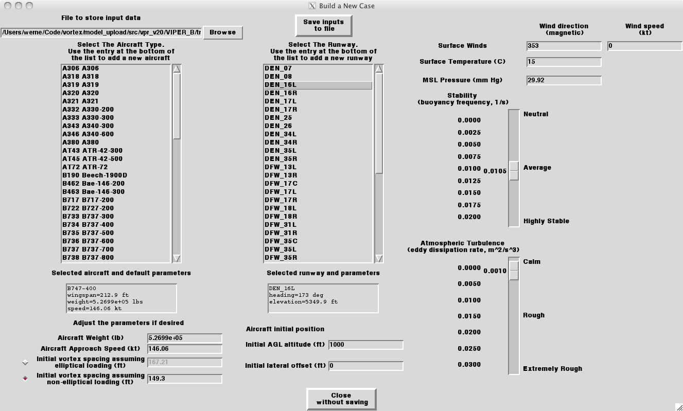

Figure VIPER GUI “Construct a new case” panel.

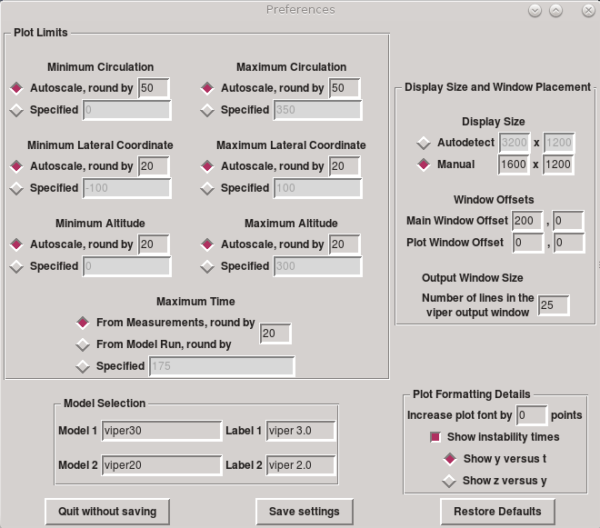

Figure VIPER GUI “preferences” window.

# 6. VIPER input files

The VIPER programs requires input data for environmental and aircraft parameters for each landing it simulates. The environmental conditions needed include atmospheric wind, temperature, and turbulence profiles and the altitude and mean surface air density of the airport where the aircraft landing occurs. Examples of the aircraft parameters include the aircraft make/model, landing weight, wingspan, and airspeed. The models also requires the starting altitude of the aircraft wake vortices and their initial separation (which is related to the aircraft wingspan and wing loading). For a particular landing case, the input data-file used by the programs named <case>.vpi and it has the following format:

1. An optional header line beginning with the # symbol and reporting file-creation details (e.g., date, time, and by what process or by whom the file was created or last edited).
2. A series of lines containing a) key, b) value, and c) description elements, which are separated by white space. An example line includes a) key = “ac_span”, b) value = “64.56”, and c) description = “Aircraft wingspan (m)”.
3. For certain keys (e.g., n_temp, i.e., the number of temperature data points in the environmental temperature profile), the value indicates the number of subsequent lines that contain the profile data (in this example, the temperature profile data).

An example VIPER input file is included below.

============================ VIPER input file=DEN03_A319_OGE_091903213256.vpi

# File created by build_database on Tue Jul 2 14:12:41 MDT 2013

units_flag 0 Units flag: 0-SI; 1-Aviation

ac_type A319 Four letter aircraft designator

ac_weight 5.3125e+4 Aircraft weight (kg)

ac_span 34.10000 Aircraft wingspan (m)

ac_speed 62.80760 Aircraft speed (m/s)

ac_b0 26.22000 Initial vortex spacing (m)

ac_y0 -0.69990 Initial aircraft offset from runway center (m)

ac_z0 231.5719 Initial aircraft AGL altitude (m)

runway DEN_16L Airport_Runway

runway_elev 1630.65 Runway elevation (m)

surf_rho 1.02000 Surface air density (kg/m^3)

flag_pot_temp 1 0 for temperature, 1 for potential temp

n_temp 13 Number of points in temperature profile

0.0000E+00 2.8737E+02

1.0000E+01 2.8737E+02

4.0000E+01 2.8752E+02

6.0000E+01 2.8754E+02

8.0000E+01 2.8757E+02

1.0000E+02 2.8762E+02

1.2000E+02 2.8770E+02

1.4000E+02 2.8805E+02

1.6000E+02 2.8837E+02

1.8000E+02 2.8865E+02

2.0000E+02 2.8902E+02

2.2000E+02 2.8934E+02

2.4000E+02 2.8959E+02

flag_cw 1 1-measured, 2-mm5, 3-proxy, 4-default, 5-AWOS

n_cw 12 Number of points in crosswind profile

0.0000E+00 1.3402E+00

1.0000E+01 1.3402E+00

2.0000E+01 2.5247E+00

3.0000E+01 3.1631E+00

4.0000E+01 4.1207E+00

5.0000E+01 4.4492E+00

6.0000E+01 4.8030E+00

7.0000E+01 5.1040E+00

8.0000E+01 5.3818E+00

9.0000E+01 5.7140E+00

1.0000E+02 6.0281E+00

1.5505E+02 6.0281E+00

flag_hw 1 1-measured, 2-mm5, 3-proxy, 4-default, 5-AWOS

n_hw 2 Number of points in headwind profile

0.0000E+00 2.0700E+00

1.5000E+04 2.0700E+00

flag_q 1 1-measured, 2-mm5, 3-proxy, 4-default

n_q 2 Number of points in eddy dissipation rate profile

0.0000E+00 1.0000E-04

1.5000E+04 1.0000E-04

nt_meas_p 8 Number of port vortex position measurements

6.2500E+00 -3.0996E+00 5.5500E+01

1.8830E+01 3.1700E+01 3.4000E+01

2.2490E+01 3.9800E+01 2.9000E+01

3.6020E+01 5.7800E+01 2.7600E+01

3.9530E+01 6.8800E+01 3.1500E+01

5.2890E+01 9.1300E+01 3.3600E+01

5.6470E+01 9.4400E+01 3.0300E+01

6.9900E+01 1.0920E+02 3.3700E+01

nt_meas_s 7 Number of starboard vortex position measurements

6.1900E+00 4.0700E+01 5.6000E+01

1.8870E+01 8.8400E+01 3.4300E+01

2.2480E+01 9.6400E+01 3.0400E+01

3.5900E+01 1.5500E+02 3.5500E+01

3.9570E+01 1.6250E+02 3.6100E+01

5.2820E+01 2.0790E+02 4.0600E+01

5.6650E+01 2.1740E+02 4.2300E+01

nt_meas_cir_p 8 Number of port vortex circulation measurements

6.2500E+00 5.0550E+02

1.8830E+01 4.8200E+02

2.2490E+01 4.8260E+02

3.6020E+01 4.4320E+02

3.9530E+01 4.1310E+02

5.2890E+01 3.9440E+02

5.6470E+01 3.5050E+02

6.9900E+01 2.5860E+02

nt_meas_cir_s 7 Number of starboard vortex circulation measurements

6.1900E+00 5.0470E+02

1.8870E+01 4.7500E+02

2.2480E+01 4.7120E+02

3.5900E+01 4.3100E+02

3.9570E+01 4.2540E+02

5.2820E+01 3.5560E+02

5.6650E+01 3.4940E+02

# 7. VIPER output files

For each landing simulation, the VIPER 2.0 and 3.0 programs produce a model-output file named <case>.vpr20 and <case>.vpr30, respectively. These files contain the model’s predictions for the aircraft port and starboard wingtip-vortex trajectories and circulation evolutions. For a particular landing case, the output data-file has the following format:

1. A header line beginning with the # symbol.
2. Seven elements separated by white space which contain a) the modeled time, b) the port-vortex lateral position, c) the port-vortex vertical position, d) the port-vortex circulation, e) the starboard vortex lateral position, f) the starboard vortex vertical position, and g) the starboard vortex circulation.

A portion of the example output file DEN03_A319_OGE_091903213256.vpr20 is included below.

========================= VIPER output file=DEN03_A319_OGE_091903213256.vpr20

#time y_p z_p cir_p y_s z_s cir_s

0.000 -1.3810E+01 2.3157E+02 -2.8325E+02 1.2410E+01 2.3157E+02 2.8325E+02

1.525 -9.5565E+00 2.2898E+02 -2.7718E+02 1.6664E+01 2.2898E+02 2.7718E+02

3.050 -5.3786E+00 2.2642E+02 -2.7128E+02 2.0843E+01 2.2642E+02 2.7128E+02

4.575 -1.2848E+00 2.2387E+02 -2.6554E+02 2.4938E+01 2.2387E+02 2.6554E+02

…

# 8. VIPER file listing

Section 8.1. contains the VIPER file layout and Tables 8.1 to 8.8 contain brief descriptions of each file.

## 8.1. VIPER Source-Code Layout

**Docs/**

**VIPER30-UsersGuide.pdf**

**VIPER30-UsersGuideFigures.pdf**

**Tutorials/**

**Lesson01.m4v**

**Lesson02.m4v**

**Lesson03.m4v**

**Lesson04.m4v**

**Lesson05.m4v**

**Lesson06.m4v**

**ViperMS/**

**Run_model.exe**

**ViperGui.pl**

**ViperUpdate.pl**

**Code/**

**compute_state.f**

**execute_model.f**

**igsolv.f**

**mainfuncs.f**

**Makefile**

**read_inputs.f**

**read_prefs.f**

**rte_base.f**

**run_model.f**

**set_model_params.f**

**set_vpr20_params.f**

**spline_subs.f**

**viper20.f**

**viper30.f**

**viper_ige.f**

**write_inputs.f**

**DataBase/**

**AC_specs.csv**

**AirportData.csv**

**Input/**

**SFO01_OGE_B744_091001182642.vpi**

**…**

**Output/**

**SFO01_OGE_091001182642.limits**

**SFO01_OGE_091001182642.meas_cir_p**

**SFO01_OGE_091001182642.meas_cir_s**

**SFO01_OGE_091001182642.meas_cw**

**SFO01_OGE_091001182642.meas_edr**

**SFO01_OGE_091001182642.meas_hw**

**SFO01_OGE_091001182642.meas_init**

**SFO01_OGE_091001182642.meas_state**

**SFO01_OGE_091001182642.meas_yz_p**

**SFO01_OGE_091001182642.meas_yz_s**

**SFO01_OGE_091001182642.vpr20**

**SFO01_OGE_091001182642.vpr20_params**

**…**

**State/**

**main.opt**

**new_case.par**

**previous.lst**

**Template/**

**Circ2.png_src**

**circ.png_src**

**circ.ps_src**

**edr.png_src**

**edr.ps_src**

**N.png_src**

**N.ps_src**

**temp.png_src**

**temp.ps_src**

**traj2.png_src**

**traj.png_src**

**traj.ps_src**

**wind.png_src**

**wind.ps_src**

**y2.png_src**

**y.png_src**

**y.ps_src**

**z2.png_src**

**z.png_src**

**z.ps_src**

**Table 8.1: VIPER Documentation Files in Docs/**

|  |  |  |
| --- | --- | --- |
| **#** | **Filename** | **Description** |
| 1 | **VIPER30-UsersGuide.docx** | This file. |
| 2 | **Tutorials/Lessons.html** | Video tutorial list and access page |
| 3 | **Tutorials/Lesson01.m4v** | Video tutorial 1: Overview of installed components |
| 4 | **Tutorials/Lesson02.m4v** | Video tutorial 2: Introduction to the Graphical User Interface |
| 5 | **Tutorials/Lesson03.m4v** | Video tutorial 3: Managing the run list |
| 6 | **Tutorials/Lesson04.m4v** | Video tutorial 4: Using the run controls |
| 7 | **Tutorials/Lesson05.m4v** | Video tutorial 5: Constructing a new case |
| 8 | **Tutorials/Lesson06.m4v** | Video tutorial 6: Adding aircraft and airports to the database |
| 9 | **HTML/1ms_cw_example.html** | Animation: VIPER IGE in crosswind |
| 10 | **HTML/igeSameCal_040.html** | Animation: VIPER IGE 747 example |

**Table 8.2: VIPER Database Files in DataBase/**

|  |  |  |
| --- | --- | --- |
| **#** | **Filename** | **Description** |
| 1 | **AC_specs.csv** | Aircraft parameters file |
| 2 | **AirportData.csv** | Airport parameters file |

**Table 8.3: VIPER Fortran File Source Code Listing in Code/**

|  |  |  |
| --- | --- | --- |
| **#** | **Filename** | **Description** |
| 1 | **compute_state.f** | Obtain atmospheric thermodynamic profiles given temperature. |
| 2 | **execute_model.f** | Routine to call either the VIPER 3.0 or VIPER 2.0 model. This routine is required for cases with significant headwinds where the respective model is called repeatedly with different initial altitudes. |
| 3 | **igsolv.f** | Derivative and Runge-Kutta routines needed for viper_ige.f. |
| 4 | **mainfuncs.f** | Linear interpolation. |
| 5 | **Makefile** | Input data processing routine to categorize atmospheric profiles. |
| 6 | **read_inputs.f** | Read landing input data, new format. |
| 7 | **read_prefs.f** | Read the user preference data as set by the GUI. |
| 8 | **rte_base.f** | Specify OGE wake entrainment coefficients using NWRA lab data. |
| 9 | **run_model.f** | VIPER calling routine. |
| 10 | **set_model_params.f** | Generic routine to set the specified model parameters. |
| 11 | **set_vpr20_params.f** | Specify VIPER model coefficients. |
| 12 | **Viper20.f** | VIPER version 2.0 main routine. |
| 13 | **Viper30.f** | VIPER version 3.0 and supporting subroutines. |
| 14 | **viper_ige.f** | VIPER IGE subroutine and supporting routine. |
| 15 | **write_inputs.f** | Routine to save VIPER’s input parameters. |

**Table 8.4: VIPER GUI Plotting Template Files in Template/**

|  |  |  |
| --- | --- | --- |
| **#** | **Filename** | **Description** |
| 1 | **circ2.png_src circ.png_src, circ_ps_src** | Aircraft port and starboard circulations vs time |
| 2 | **edr.png_src, edr.ps_src** | Atmospheric turbulence vs altitude |
| 3 | **N.png_src, N.ps_src** | Atmospheric stability vs altitude |
| 4 | **temp.png_src, temp.ps_src** | Atmospheric temperature vs altitude |
| 5 | **traj2.png_src traj.png_src traj.ps_src** |  |
| 6 | **wind.png_src, wind.ps_src** | Atmospheric wind vs altitude |
| 7 | **y2.png_src y.png_src, y.ps_src** | Aircraft port and starboard lateral positions vs time |
| 8 | **z2.png_src z.png_src, z.ps_src** | Aircraft port and starboard lateral positions vs altitude |

**Table 8.5: VIPER Support Files in ViperMS/**

|  |  |  |
| --- | --- | --- |
| **#** | **Filename** | **Description** |
| 1 | **Run_model.exe** | VIPER executable program |
| 2 | **ViperGui.pl** | VIPER Graphical User Interface Perl script |
| 3 | **viperUpdate.pl** | VIPER and GUI update Perl script |

**Table 8.6: VIPER GUI Support Files in State/**

|  |  |  |
| --- | --- | --- |
| **#** | **Filename** | **Description** |
| 1 | **main.opt** | GUI auto-saved main-panel settings |
| 2 | **new_case.par** | GUI auto-saved user-specified new-case variables |
| 3 | **previous.lst** | GUI auto-saved runlist |

**Table 8.7: VIPER Input File for a single landing <case> in Input/**

|  |  |  |
| --- | --- | --- |
| **#** | **Filename** | **Description** |
| 1 | **<case>.vpi** | VIPER aircraft landing input data file |

**Table 8.8: VIPER Output Files for a single landing <case> in Output/**

|  |  |  |
| --- | --- | --- |
| **#** | **Filename** | **Description** |
| 1 | **<case>.limits** | Suggested plot limits for output graphs |
| 2 | **<case>.meas_cir_p** | Input port circulation data vs time |
| 3 | **<case>.meas_cir_s** | Input starboard circulation data vs time |
| 4 | **<case>.meas_cw** | Input cross wind data vs altitude |
| 5 | **<case>.meas_edr** | Input atmospheric turbulence data vs altitude |
| 6 | **<case>.meas_hw** | Input head wind data vs altitude |
| 7 | **<case>.meas_init** | Input initial vortex position and velocity and cross wind |
| 8 | **<case>.meas_state** | Atmospheric thermodynamic profiles vs altitude |
| 9 | **<case>.meas_yz_p** | Input port position data vs time |
| 10 | **<case>.meas_yz_s** | Input starboard position data vs time |
| 11 | **<case>.vpr20** | VIPER 2.0 output vortex position and circulation data vs time |
| 12 | **<case>.vpr30** | VIPER 3.0 output vortex position and circulation data vs time |
| 13 | **<case>.vpr20_params** | VIPER parameters used |

# VIPER 3.0 model description

The VIPER 3.0 model is described in detail in the separate document viper30.pdf.

# Bibliography

Delisi, D.P., R.E. Robins, and M.P. Lelong, “Laboratory and Numerical Experiments Supporting the Improvement of Vortex Predictions in the Fastwake Numerical Code and Studies of Velocity Decay in Stratified Turbulence”, Final Report for Tasks 1 and 3 for ONR Contract N00014-99-C-0169, 30 Nov. 2005.

Crow, S.C., “Stability theory for a pair of trailing vortices”, AIAA J., 8, 2172-2179 (1970).

Delisi, D.P. and R.E. Robins, “Short-Scale Instabilities in Trailing Wake Vortices in a Stratified Fluid”, AIAA Journal, Vol. 38, No. 10, October 2000.

Proctor and Switzer 2000, “Numerical Simulation of Aircraft Trailing Vortices”, 9th Conference on Aviation, Range and Aerospace Meteorology, 11-15 September 2000, Orlando Florida, American Meteor. Soc., 511-517.

Garten, J.F., J. Werne, D.C. Fritts, and S. Arendt, “Direct numerical simulations of the Crow instability and subsequent reconnection in a stratified fluid”, J. Fluid Mech., 426, 1-45.

Sarpkaya, T., “Decay of wake vortices of large aircraft”, AIAA Journal, 36, 1671-1679 (1998).

Delisi, D.P., and G.C. Greene, “Experimental Measurements of the Evolution of a Vortex Pair in Nonstratified Fluid Par2: Low Reynolds Number Wings and Vortex Wake Characterization”, 47th AIAA Aerospace Sciences Meeting Including The New Horizons Forum and Aerospace Exposition, 5-8 January 2009, Orlando, FL, 1-11.

Delisi, D.P. and R.E. Robins, “Laboratory and Numerical Studies of the Effects of Shear on 3D Vortex Evolution”, Final Report for ONR Contract N00014-01-C-0316, delivered to the Office of Naval Research, June 2005.

Stephan, A., F. Holzäpfel, and T. Misaka, “Aircraft Wake-Vortex Decay in Ground Proximity – Physical Mechanisms and Artificial Enhancement”, 4th AIAA Atmospheric and Space Environments Conference, 25-28 June 2012, New Orleans, Louisiana, USA.

Doligalski, T.L. and J.D.A. Walker, “The boundary layer induced by a convected two-dimensional vortex”, J. Fluid Mech., 139, 1-28 (1984).